System Specification

Trainee Information Systems

- Document Control

Document change record
Date | Author | Version | Reference
30 September | Rob Pink | 0.1 | Draft
7 October | Rob Pink | 0.2 | Draft
26 October | Rob Pink | 0.3 | Draft for wider circulation and comment
6 November | Benjamin Witton | 0.4 | User archetypes added to the appendix

Named Reviewers
Sue Mulcock | Commercial Specialist - DH Procurement Services
James Clayton | Senior Associate Commercial Business Services - Hill Dickinson LLP
James Freed | Chief Information Officer
Professor Nicki Latham | Executive Director of Performance and Development
Benjamin Witton | Assistant Project Manager

Reviewer groups
TIS Project Board members
National Education Commissioners Network
COPMED Senior Manager’s Forum
Pharmacy Network
School of Healthcare Scientists
Dental Manager’s Network
National Informatics Hub

- Contents

1. Document Control 2
2. Contents 3
3. About this documents 6
PART A Forward and context 7
4. Terminology and notes 7
5. Background of Health Education England 7
6. Background of the Trainee Information System project 7
7. Primary objectives of the system 9
PART B – Supplier guidance 10
8. How to use this document 10
9. Quick wins 12
10. How will the HEE work with the supplier? 12
11. What is the vision of the system? 13
12. Maximising innovation 14
13. Understanding HEE and how the system “fits” 15
14. Overarching principles 16
PART C Functional requirements 18
15. Disclaimer 18
16. COMMON system requirements 19
16.1. Person record 19
16.2. Person-types 22
16.3. Training Programme 24
16.4. Curricula requirements 27
16.5. Training post management 28
16.6. Placement management 29
16.7. Starter processes 30
16.8. Leaver processes 31
16.9. Reporting 32
16.10. User experience 33
16.11. System organisation 35
17. SPECIALIST system requirements 37
17.1. Assessment management 37
17.2. Educational attainments 38
17.3. Revalidation of trainee doctors 39
17.4. Trainer management 40
17.5. Self-service 41
17.6. Approvals 42
17.7. Finance management 43
17.8. Communications 45
17.9. Content management 46
17.10. Quality management of learner’s education and training 47
17.11. Interfaces and data exchange 49
17.12. Other requirements 51
18. GENERAL system requirements 52
18.1. E-document and paperless working 52
18.2. Surveys and questionnaires 53
18.3. Dashboards 54
18.4. Training course management 55
18.5. Study leave management 56
18.6. Data-warehousing 57
18.7. Case management 58
18.8. Electronic portfolio (e-portfolio) 60
19. Non-functional and technical requirements 62
19.1. System hosting 62
19.2. System development 62
19.3. Performance and usability 63
19.4. Capacity and scalability 63
19.5. Archiving 63
19.6. Availability, Resilience, Reliability & Recoverability 64
19.7. Application accessibility 64
19.8. Application identity 64
19.9. Application security 65
19.10. System audit 66

Figure 1 - The system overview 10
Figure 2 - Approach to implementation 12
Figure 3 - Illustrative and simplified HEE-supplier interaction model 13
Figure 4 - Innovation model 15
Figure 5 - HEE's operating environment 16
Figure 6 - Illustrative learner lives 23
Figure 7 - Illustrative training programme 26
Figure 8 - Training programme 31

Annex A – Abbreviations and definitions 64
Annex B - Structure of HEE 65
Annex C - Definitions of learners 66
Annex D - Illustrative use of the system 67
Annex E - Illustrative information standards (non-exhaustive) 69
Annex F - Illustrative stakeholders 70
Annex G - Further information (links) 71
Annex H - Assumptions on system metrics 72
Annex I - Description of some directly managed learners 73
Annex J - Illustrative high-level processes for some learner-types 74
Annex K - User personas / archetypes 85

Table 1 - Primary objectives of the system 10
Table 2 - Codes for requirement priority 12
Table 3 - Corporate vision of the system 14
Table 4 - User vision of the system 15
Table 5 - System overarching principles 17
Table 6 - Person categories 20
Table 7 - Person record requirement 21
Table 8 - person-type requirements 24
Table 9 - Training programme requirements 26
Table 10 - Curricula requirements 27
Table 11 - Training post management requirements 28
Table 12 - Placement management requirements 29
Table 13 - Leaver requirements 32
Table 14 - Reporting 32
Table 15 - User experience 34
Table 16 - System organisation 35
Table 17 - Assessment requirements 36
Table 18 - Educational attainments 37
Table 19 - Revalidation of trainee doctors 38
Table 20 - Trainer management 39
Table 21 - Self-service requirements 40
Table 22 - Approvals requirements 41
Table 23 - Finance management requirements 43
Table 24 - Communications requirements 44
Table 25 - Content management requirements 45
Table 26 - Quality management requirements 46
Table 27 - Data exchanges in place, or possible 47
Table 28 - Interface and data exchange requirements 48
Table 29 - Other requirements 48
Table 30 - E-document and paperless requirements 51
Table 31 - Surveys and questionnaire requirements 52
Table 32 - Dashboard requirements 52
Table 33 - Training course requirements 53
Table 34 - Study leave requirements 55
Table 35 - Data warehousing requirements 55
Table 36 - Case management requirements 57
Table 37 - e-portfolio requirements 58
Table 38 - System hosting 59
Table 39 - System development 59
Table 40 - Performance and usability 60
Table 41 - Capacity and scalability requirements 60
Table 42 - Archiving requirements 61
Table 43 - Availability, Resilience, Reliability & Recoverability requirements 61
Table 44 - Application accessibility requirements 61
Table 45 - Application identity requirements 62
Table 46 - Application security requirements 62
Table 47 - System audit requirements 63

- About this documents

Over the last four months the HEE user community and stakeholders submitted 110 requirements documents, with each containing many individual requirements and ideas for what they wanted in the system (TIS). These requirements have been consolidated into this document.

This document is intended to inform potential suppliers of the high-level business requirements for software as a services to support the effective management of trainees and learners, henceforth collectively referred to as learners, across HEE.

It is intended that this document will enable suppliers to understand the framework and boundaries of the system and in so doing, be able to make objective and informed decisions on their approach and costs associated with the development, implementation and in-service support.

The document forms the vision for an information system to be procured that will underpin the effective management of learners across a range of functional areas.

The document is split into three parts, as follows:

Section | Description
PART A | Provides the contextual narrative.
PART B | Provides guidance for suppliers.
PART C | Provides the functional and non-functional, or outputs and specification. This is sectioned into the following requirements:  - Core functional requirements  - Specialist functional requirements  - General functional requirements  - Non-functional and technical requirements

- Forward and context

- Terminology and notes

Due to differences in terminology between functional areas, local teams, and with stakeholders the Trainee Information System (TIS) project has sought to introduce consistent terminology, and Annex A provides an overview.

It should be noted that throughout the project to date, terminology has been evolving. For readability the following should be noted:

- The term “the system” is used to describe the information system also known as TIS.
- The term “learner” is used to describe trainees and learners as the system (TIS) should not differentiate. In some cases trainee will be used for historical convenience.
- The term “trainer” is a coverall description that may include teacher, tutor, supervisor, trainer, mentor or any similar role.
- The term “user” is used to describe any person who uses the system, for whatever role. It is also used interchangeably admin or operator.
- The terms “directly managed” and “commissioned learners” is still used to illustrate the core business processes associated with that learner-type. The difference remains as a convenient demarcation of system functions, but are expected to diminish in use through time.

The use of the term “information system” or “system” in this document does not imply or assume a single system, and may comprise many separate components, systems and/or modules.

- Background of Health Education England

HEE’s organisational ancestry is complex, with a variety of organisations coalescing over the last decade into a collection of dispersed functional networks, and finally being incorporated into HEE in 2013 when the Strategic Health Authorities (SHAs) were abolished under the Health and Social Care Act 2012.

HEE became a Non-Departmental Public Body (NDPB) on 1st April 2015 and is comprised of 13 local teams known as Local Education and Training Boards (LETBs). These are organised into for Geography areas, as detailed in Annex B.

The role, governance and structure of HEE are described on HEE’s website at https://hee.nhs.uk.

- Background of the Trainee Information System project

HEE inherited a complex and disparate portfolio of information systems that are used to manage trainees and learners associated with HEE-funded and supported training programmes and initiatives. The number of information systems and their functional scope and scale has resulted in an uncoordinated, expensive and difficult to integrate information system landscape, that is, and will continue to constrain HEE’s ability to develop their business.

In early 2014 a paper was produced that outlined plans to develop a national information system to support trainees, primarily medical and dental trainees. This work developed slowly but ended with an initial options appraisal which identified the need for a multi-professional approach with a wider scope – i.e. not just medical and dental functions.

In November 2014 the Trainee Information System (TIS) project was initiated with the appointment of a part-time (later full-time) Programme Manager. The initial focus was on understanding the scope of TIS with the steer any outcome should be multi-professional in some form.

At the same time the need to mobilise potential suppliers was identified and a supplier engagement was also initiated and to date two supplier days have been run. These events sought to promote the forthcoming procurement and to maximise interest from “the market”.

The options appraisal carried out in late 2015 and early 2015 identified and differentiated between two types of trainees and leaners, bulleted below with definitions shown in Annex C:

- Trainees in Directly Managed Programmes (DMP), where HEE has a direct and often regulatory relationship with the trainee, such as doctors, dentists, public health, scientists and pharmacists were groups that fell into this category.
- Learners associated with Commissioned Programmes (CP) where the relationship with a learner is typically through a third party, such as a university.

With DMP the business processes were similar across all local teams due to a higher level of national working and alignment to regulatory frameworks. However, with CP it was found that processes and practices were move diverse between local teams due to variation in legacy management arrangements and information systems used.

The outcome of the options appraisal highlighted the different types of learners (i.e. DMP and CP) and offered the following outputs which were endorsed by Project Board.

- The requirement for DMP was to maximise what could be delivered through any new information system so that the functional outputs were over and above current provision, characterised by a high degree of process standardisation across a range of operational functions. It was decided the functionality would exceed that offered by the existing information systems in use.
- Due to the lack of business alignment within Commissioned Programmes due to myriad legacy arrangements and the immaturity of organisational strategy, a “minimum” development outcome was selected. This has evolved into a two-stage approach.
  - Stage 1 is a process of internal alignment and standardisation to ensure local teams are all collecting similar data and using existing information systems optimally.
  - Stage 2 would be to transition of local teams into a “TIS for all”. This is highly dependent on a national strategy in this space to define the parameters of how COP will be managed. Therefore there a degree of uncertainty as to the extent of the CP requirement. However, suppliers will be required to build the functionality into the common product and other areas indicated in the requirement. This is possible due to the similarity between DMP and CP at the “core” level.

For the system therefore, the differentiation between CP and DMP requirements is being removed, with the concept of learner-types being introduced. For example, if the learner is a trainee doctor then the system would behave differently than if the learner was an undergraduate student, however, the core system would be common.

- Primary objectives of the system

The system will produce the following organisational benefits.

Table 1 - Primary objectives of the system
 | Theme | Description
1 | Data management | Improved data reliability and availability to improve decision making e.g. understanding workforce dynamics impacting workforce planning and commissioning decisions.
3 | Process harmonisation | Greater convergence towards standardised processes will support the move towards “One HEE” and improved system-wide efficiencies and productivity.
3 | Reduced systems | To reduce the number of information systems in use by introducing national systems, such as the subject of this document.
4 | Risk | Reducing corporate risk e.g. from data loss or the impact of a serious omission caused by data confusion that impacts the management of a learner.
5 | Finance | Providing improved value for money.

- – Supplier guidance

- How to use this document

The requirements for the system are documented in PART C and these provide the framework, or boundaries, for suppliers to develop their proposals. They are meant to enable suppliers to understand the scale and scope of the requirement and in so doing, be able to make informed and objective judgements of the work to develop the system, implement and provide support through the system’s life.

As the system will be developed using an Agile approach, the requirements should not be taken as definitive or limiting any further requirement elaboration/discovery and process definition activity that will be necessary as part of a successful iterative system-development approach. Indeed, there is an expectation that further requirements elaboration will be necessary post tender, alongside process alignment and standardisation activity between the supplier, the user community and the TIS Project team, and this will derive a detailed set of business requirements that will inform system development and build.

Each requirement area contains a broad description of the requirement context, the potential and latitude for innovative solutions and the high-level requirements.

In the course of the work to date it has been possible to section the functional requirement into functional areas, as shown in Figure 1. This helps to understand how the system could be built and function.

Figure 1 - The system overview

The interpretation of the system requirement categories are:

- Common – These are the requirements that are likely to be common for all system entities and enable learners and associated processes to be managed in one system. In essence, this represents functions that will be common features for the management of “directly managed” and “commissioned” learners.
- Specialist – These include functions that are likely to be specific to HEE and as such will need to be built as bespoke products.
- General – This represents products that could be potentially procured as “commercial off the shelf” (COTS) items, or products built by the supplier. This provides HEE with potential and flexibility to remove system components and replace with other products, or to run more than one product in the same space.
- Non-functional and technical – Encompasses requirements within which the system will operate and be managed.

Within the each requirement area there structured set of information, as follows:

- Title – A section reference and heading.
- Overview – A high-level description and narrative to guide suppliers on the context.
- Requirements and specific notes – An indicator of the level of innovation and development we feel a supplier can apply to the, with informative examples as appropriate.
- Table – Detailing the view of the known requirements and to provide the boundaries and framework for future discovery and requirement elaboration. Against each requirement is an indication whether the requirement is “Must”, “Should” and “May” and this is described in Table 2.

Table 2 - Codes for requirement priority
Code | Description
Must (M) | This will indicated that the definition is an absolute requirement within the specification.
Should (S) | This will indicate that there are valid reasons or circumstances where a particular requirement is ignored, but the full implications must be understood and carefully weighed before choosing a different course.
May (Ma) | This will indicate that a requirement is optional.

Suppliers should consider how they intend to deliver the finished system using as a guide the process illustrated in Figure 2.

Figure 2 - Approach to implementation

Due to the extent of the requirement, it is conceivable and desirable that the different functional components are delivered in concurrent and sequential phases. Suppliers therefore have the latitude to propose how this can be accomplished, starting with the development of the common system.

Supplies should note that due to some uncertainty as to the extent of commissioned programmes being incorporation into the system there is likely to be a staggered approach to development and (if appropriate) for the inclusion of commissioned programmes. The common system components should contain the ability to incorporate commissioned programmes.

Suppliers are therefore guided to concentrate on directly managed learners, although the system should be capable of adding commissioned programmes through abstraction. How commissioned learners will be incorporate into the system will necessitate further discovery and requirements elaboration, probably towards the end of year 1 of the contract. Regardless, Annex D provides a view of the likely coverage in time, although this will be solidified throughout the further discovery and requirements elaboration.

- Quick wins

The supplier will be expected to propose “quick wins” in the early stages of the project, so as to enhance and build confidence in the project approach and to set the foundations for wide stakeholder support and participation.

- How will the HEE work with the supplier?

HEE recognise that this is a complex system development and implementation project, and that the supplier will need to work within a supported and supportive environment with a high degree of participatory working.

To enable this to happen, HEE will set up a structure that enables the supplier to optimise interaction and benefit with the user-base and the project team, in the form of User Groups headed by product owners at a functional level, and a System Authority that works to optimise interaction and participation with the supplier. The System Authority will also act as the “control” and assurance for the developing system.

Figure 3 shows the HEE-supplier interaction in a simplified form, so that some specific activities and roles are not shown, although implied. This model will be adapted to support the agreed approach outlined I the supplier’s proposal and their project management approach.

Figure 3 - Illustrative and simplified HEE-supplier interaction model

- What is the vision of the system?

In reality there are two visons for the system that the supplier will need to consider:

- A high level strategic, or corporate view that looks at the transformation by stating the “what is” to the “what is to be” situation. This is shown in Table 3 below.

A user-centric vision based on user’s current experience. Some of this is reinforced by the user personas in
- Annex K. This is shown in Table 4 below.

Table 3 - Corporate vision of the system
What is | What is to be
A large number of costly information systems across LETBs. | A rationalised and managed information system estate provisioned at lower cost.
Lack of reliable and easily produced data outputs able to support decision-making. | A transparent data model and associated process alignment and data repository supporting business reporting.
Lack of visible value for money | To demonstrate value for money.
Inconsistent involvement of system users | To put users at the heart of developing and using the system.
Inconsistent involvement of stakeholders | To set up an environment where stakeholders are able to efficiently interact with e.g. data sharing.
Variable and inconsistent governance | Demonstrable high standards of information governance and financial/procurement and contract management.

Table 4 - User vision of the system
Issue | Resolution
Users are frustrated by data existing in one or more systems meaning that a record many be repeated several times, and therefore need updating several times. | The system will replace many systems in HEE will aim to create a single learner record. Where there is duplication with stakeholders then well specified data exchange processes should ensure a good degree of alignment.
The amount of re-keying data is very time-consuming and increases the risks of errors. | The system must aim eliminate the need to re-key data by having reliable data exchange processes and data validation processes.
Users find that some processes are not supported on current systems, often necessitating spreadsheet processes being set up which duplicate data and force re-keying. | The system will seek to support processes and the way users work and this will be done by changing the way we develop systems by constantly involving the user community.
Users find it difficult to run reports. | The system will aim improve reporting alongside a simplified dataset which users understands.
Users waste time trying to work out how to do things, find records and correct errors. Basically, many systems are difficult to use! | The users will help design how the system looks, feels and works so that routine tasks are easier. In addition, the system will seek to automate many routine tasks and introduce workflows to help users plan and order their work.

- Maximising innovation

Suppliers need to consider how innovative solutions can be introduced into the system to improve process efficiency, data flows and effective user interaction, including in the following areas:

- The use of the system and user experience.
- Workflows and process automation.
- Data import and export to remove re-keying and improve efficiency.
- Common system processes with variation, rather than many different processes.
- Reduce system administration.
- Support for rapid development cycles.
- Mobile or PC apps or plugins to enable improved use and system interaction.

The supplier should ensure they are receptive to innovative solutions from the users and feel empowered to develop, suggest and recommend innovative solutions to resolve development issues and problems.

We believe that innovative solutions can be both supplier-led and facilitated if they are able engage with the users and develop participatory relationships to maximise innovation, especially in the three areas described in Figure 4.

Figure 4 - Innovation model

- Understanding HEE and how the system “fits”

Understanding HEE’s operating environment is important to appreciate how the system will work and support operational and strategic activity.

HEE operates in an ever changing environment in the following areas:

- Learner roles are constantly evolving. The training and education of a doctor, or nurse is very different today when compared to a decade ago, and undoubtedly through the life of the system how HEE manages education and training will also change.
- No part of the NHS is exempt from change brought about by national policy. There is a chance of organisational change that would impact the system through its life and this will present both a threat and an opportunity.
- The role and structure of HEE will also evolve through the life of the system.

The LETBs are instrumental in the management and administration of learners and oversee a complex set integrated processes between themselves, training provides, education providers, regulators and other national organisations. A “look-down” view of HEE’s operating environment is shown in Figure 5.

Figure 5 - HEE's operating environment

- Overarching principles

Table 5 outlines the overarching principles and requirements for the information system and associated development, implementation and maintenance.

These principles will help to shape the functionality required to meet the needs of the users and stakeholders of the system.

Table 5 - System overarching principles
ref | Principle
 | Learners must be associated with a training programme and the training programme should be the key determinator of process.
 | The system must support a “role-based” approach where the role or “type” dictates process.
 | The system must adopt existing data standards, for example the NHS Information Standards, NHS data Dictionary and the Higher Education Statistics Agency and others.
 | Access and use of the system must not significantly increase a user’s workload and should be as efficient, or more efficient, as current process.
 | People accessing the system can only see what they are meant to see for their job role.
 | The system will be accessed one a single set of login credentials.
 | The system should be available 24 hours a day, 365 days a year.
 | The system requirements will reduce the variability of systems and processes across HEE.
 | The system must support the use of existing data standards and guidance and also be flexible enough to support emerging new standards and guidance.
 | The system should support any regulatory or nationally defined or mandated approach to the management of learners and trainers.
 | The system must support improvements to the way in which services are planned, commissioned and delivered.
 | The system must support, the capture, storage, use, sharing and reporting of learner information.
 | The system should be the primary resource for the management of learners and for the production of information relating to learners to support research, workforce planning and commissioning.
 | The system must be able to provide secondary uses data in order to support the needs of a variety of stakeholders, as shown in Annex F.
 | The system will be able to accommodate bespoke and one-off data importing processes.
 | There will be no data duplication within the system.

- Functional requirements

- Disclaimer

The requirements outlined in PART C should not be taken as complete or definitive. In addition, the layout of the requirements should not be taken as a suggested data model. Suppliers should not consider themselves constrained by the way the requirements are presented and take this as the suggested future system architecture.

- COMMON system requirements

The common requirement is the management of the learners and the associated training programmes. These two components are central to the success of the system and suppliers need to consider a data model that enables these two system elements to work in a variety of complex and simple situations.

The system will also contain other people records who are not learners. In some cases these will be trainers, supervisors, tutors (hereinafter referred to collectively as “trainers”) and a number of other roles supporting trainees which in many cases will be associated with managing learners and trainers. In other cases, people records will consist of self-registered service users such as people using course booking.

  - Person record

Overview

This section and the next (S. 16.2) are very closely connected and it may be easier to view them as a single section. It has been sectioned for convenience.

HEE’s core activity is the education and training of learners, so it is logical that central to the system is the person record.

In this context, the person record comprises any named record on the system that falls into the following person categories.

Table 6 - Person categories
Category | Description
Learner | This is any named person on the system who is being managed towards an educational or training outcome directly, or with oversight of HEE.
Trainer | This is a person who participates in the management of a learner in a formal support capacity.
Admin or operator | This is a person who manages a process, typically a member of HEE staff, or other delegated authority e.g. Trust HR.
Registered user | A person who registers separately top access HEE services, e.g. to book a course, but who is not any of the above.
Note - A trainer or learner may also be an admin if they are involved in managing process.

Simplistically, a person record is a core dataset of personal information. The composition of a person record provides key identification information, equality and diversity information, contact information and other data attributes which are associated with an individual on a one-to-one basis.

The construction of how the person record links and integrates with other system attributes is for the supplier to determine within the system principles.

Requirements and specific notes

Suppliers will need to work with users to develop a core person dataset and any specifics that relate to person categories.

The supplier may need to look at how data is created and maintained throughout the person’s life in order to maximise automation and alignment to existing data standards, including how data in imported, or interfaced into the system.

This should be a reasonably straightforward area to develop as it is likely to focus on what person-related data is necessary and required.

With person fields it may be appropriate to anonymise data depending on the access permissions of the viewer.

Table 7 - Person record requirement
No | Requirement | Note
 | The system will hold personal details in a form that is efficient, including in the following areas.  - Personal name details, including legal and “used” surname.  - Personal contact details, such as home address, telephone and email and email  - Equality and diversity and other sensitive personal data as defined under the Data Protection Act.  - Professional registration details, noting that in some cases these may be linked with regulators (e.g. GMC).  - Educational qualifications and achievements.  - Unique ID numbers, such as HEI references, NI number and other attributes.  - Contract information e.g. WTE and other details pertaining to the “self”, supernumerary.  - Immigration status | Data may be derived / managed from interfaces e.g. GMC number  Some data is relevant only to that person-category and learner-type.  Postcode integration would be helpful for some services e.g. person-registration.  Equality and diversity information to include Northern Irish requirements. | M
 | The system will manage person-types as the principle determinator of how the person is managed, or manages. | For example how they are connected (or not) to a training programme. | M
 | Management of a learner number probably derived from training programme “stock”, with format and composition of numbers and associated processes learner-type specific. | How this is done is probably a feature of training programme management. | M
 | History of changes and a digest of educational and training accomplishments |  | M
 | The system will manage out-of-programme activity from application through to completion. With doctors this links with GMC process. | Out of programme is a break in training and covers all learners | M
 | For directly managed learners, a process to verify a photograph and other documents to assist in pre-employment checks. | Typically links with HR in NHS Trusts | S
 | Automatic collation of material for a Data Protection Subject Access Request, with information and documents ordered into an electronic file and or a printable document. |  | M
 | To receive and pass data with ESR via the Streamlined ESR and Deanery interface | See training programme (S. 17.11) | M
 | The system will manage a process for supporting Tier 2 sponsored directly managed learners. |  | M
 | The system will support processes that may change the “state” of the person record. | For learners these may applications for out-of-programme, or to change to part-time working. | M

  - Person-types

Overview

For the system to work, each person record will need to be appropriately associated to the business processes designed to support that person. As HEE’s information estate is principally directed at supporting existing learner silos this is not an issue. However, this system will incorporate all learners and trainers (etc.) so how these person records are sectioned is critical.

For example, an undergraduate nurse learner will attract a different set of business processes than (say) a trainee doctor. Noting that the determinator of process may be the training programme the learner is on.

It is conceivable and logical that to some extent the person-type can be derived from other system functions, notably the training programme (S. 16.3), but this may be too general and require further refinement.

The concept of a person-type is a possible way to associate business processes with a person record. Simply put, if you are an undergraduate student nurse then you will be in an appropriate training programme and you will not have a doctor’s assessment.

The person-type is also a way to introduce system flexibility, as changes to business processes (including new learner-types) can be confined and should not impact on others.

Learner-types

Through the life of a learner there may be many sequential and concurrent types, or there may only be one type.

Figure 6 provides two illustrative examples of how learner-types may work. The undergraduate student nurse has a simple, linear progression which ends in the completion of a degree course, whereas the trainee doctor has a more complex sequence of predictable and unpredictable learner-types. In the example, Foundation year 1 and 2 are predictable, but doing Core Medical Training is a learner choice.

All person-types either allow something to happen to a person e.g. an assessment, or enable a person to do something e.g. to administer the assessment. The type combined with the training programme will dictate how this happens.

Learners will also be allocated a training number which acts as a “counter” to indicate the numbers of learners in a particular type. The composition of the training number will differ between learner-type and may be derived from other system attributes, principally the training programme. The learner number may also be “owned” by a third party and represent a training unique code that may be “fixed” or follows that persons training progression. With doctors the learner number is known as the National Training Number (NTN) or Deanery Training Number (DRN) and the rules for the composition and creation will be different from a “counter” that may be assigned to another type of learner.

Learners will also have status, often referred to as “a state of being” that indicates details about their personal or contractual circumstances, such as whether they are full or part time, taking a break e.g. because of maternity, or to undertake a research project. The dynamics of the learner workforce, coupled with the requirements to manage the learner will dictate the range and extent of data captured. With most learner-types the need to capture this type of data is necessary as it impacts other system aspects, such as placement and post management.

Figure 6 - Illustrative learner lives
Trainer types

The term trainer covers any type of formal role that supports a learner. Some trainers may be passive, in that the data collected is rudimentary (e.g. their name) and their purpose is to be linked to a learner(s) as a reference process. Other trainers may be active and they are included in a range of processes to manage themselves and the leaner.

Other types

The other person categories (admins and operators, and registered users) may be simpler, or be managed in a different way entirely.

Requirements and specific notes

The concept of person-type to is seen as a solution to the problem of functional segmentation, for example with a learner or trainer.

Suppliers will need work with users to understand the range of types and where appropriate how types can be clustered where there are similar outputs and business processes.

Suppliers also need to consider how types can be derived and whether this is a feature of training programme management.

It is possible that the solution could be profession specific, with various sub-types e.g. as the profession is a “type” in itself. This may be an elegant and simple solution, but may also be an over-simplification of the problem of how to optimise management and of different outputs.

Table 8 - person-type requirements
No | Requirement | Note
 | The system should use person-types to dictate operational business rules and functions for each learner, trainer or person category. | Links with training programme. | M
 | Person-types can be batch added. |  | M
 | The system should be able to infer the person-type from other available information, such as a data import data item. | For example, if they have a GMC number then they are a doctor. | M
 | The person-type should be training programme linked. | The training programme may dictate what types can be associated with it. | M
 | The system will calculate the date for expected completion of training or education. This is likely to be learner-type and training programme derived, but with specific business rules. | For doctors the CCT date can be impacted by e.g. full or part-time; assessment outcome; periods of “out of programme”, sickness and maternity/paternity. | M
 | The system will detail the accumulated time in training for a learner. |  | M
 | The system will identify “orphaned” learners and trainers and who are not associated with a programme. | As an admin function | M
 | All person-types can attract costs for finance and this will require recording where appropriate. | See S. 17.7 | M

  - Training Programme

Overview

The training programme will provide the parameters that dictate what happens to a learner and how their education and training is ordered and arranged.

A training programme could be simple, locally defined and two-dimensional with very little data except a core that describes the scope and time the programme runs for. In some cases however, notably for directly managed learners, the training programme will more complex and draw data from a variety of sources and infer or populate data items.

The following non-exhaustive list indicates the construction of a training programme, also detailed in Figure 7. A training programme:

- May be fully or partially derived from the curricula.
- May hold the “stock” – or capacity, or commissions – of learner numbers that indicate the ceiling for training programme, or cohort. A training number could be held by named learner, or may be allocated as a “counter”.
- Training posts, which for some learner-types inherits detail from the training programme. Within some training programmes the training post is a critical item of that connects the learner to a placement. Currently, posts are only necessary for directly managed learners.
- Training placements represent the instance of a learner being trained and educated. It may also represent a non-training event e.g. a break from training.
- Approvals cover a series of processes whereby all, or elements of, a training programme are approved as being legitimate or fit for purpose.
- May hold the specialisms/specialties, sub specialties and special interest attributes (which may be a feature of curricula).

However, as a basic system principle any learner must belong to a training programme as the programme provides the “reason for being”.

Figure 7 - Illustrative training programme

Requirements and specific notes

How a training programme is managed to accommodate the requirements of all learner-types will require the supplier to work closely to define a common core dataset and the association between components.

Suppliers will need to consider the common datasets associated with training programmes and what the profession/type-specific requirements will be. Close work around this area will also understand how programme management can be automated and process drive.

Suppliers must consider an adaptable approach that does not hinder the evolution of training programmes.

Table 9 - Training programme requirements
No | Requirement | Notes
 | The system should treat training programmes as the key connector with the learner. | Learners and trainers must be connected with training programmes. | M
 | The training programme should contain all elements (both derived and collected) that determine the way a learner is managed. |  | M
 | The system must be able to produce training programmes that are associated with a variety of specialities / specialisms, sub specialities and special interest attributes. | These may be part of the curricula, or may exist as ad hoc attributes. | M
 | The system should be able to manage training programmes nationally, geographically, or locally with e.g. training posts or placements managed at different levels. | A national programme may have training posts managed at LETB level. | M
 | The system should allow programme management (and parts thereof) to be syndicated to third parties, such as “lead employers” |  | M

  - Curricula requirements

Overview

Learners follow a curriculum, or a similar framework that defines their education and training outputs. Curricula can be locally or nationally defined, or have a mix of local and national.

For some learner-types the curricula learning objectives will be detailed and outcomes recorded in an e-portfolio system.

Although some components of the curricula requirement are likely to be person-role derived, there is likely to be a core structure.

A learner will be on one or more curricula and on a training programme.

Requirements and specific notes

There is the potential to standardise core curricula components as part of a core data set for some curricula. The supplier should consider how curricula data can inform the training programmes.

Some curricula components could exist at post or placement level to indicate the aims of that entity, and the supplier should work with users to ensure that the level of detail is captured.

The supplier will need to work with the user community to ascertain how curricula are recorded and managed, including where curricula is unimportant and managed as a “shell” to inform the parameters of the training programme, and where curricula is a significant driver of activity when considering the management of training programmes.

Table 10 - Curricula requirements
No | Requirement
 | The system will enable the management of curricula at a local and national level. | This may include alignment with third parties who manage curricula. | M
 | The system will enable the recording of curricula delivery against an individual learner. | This may be linked with e-portfolio | S
 | The system should make it possible to map elements of the curricula to training posts, including certain generic professional capabilities. | For generic capabilities e.g. if the post offers specific opportunities | M

  - Training post management

Overview

A training post is a predefined container within which placements can be managed for directly managed learners. There are a range of different training posts, some of which are created for individual learners, while most are constant.

Typically, the training post contains information pertinent to the delivered education and training within the placement, plus other attributes, such as finance costs, placement constraints and other parameters.

For most commissioned programmes the training post is not relevant as learners are students and the post/placement is conceptually the same thing as these learners do undertake placements. The system should introduce this capacity pending decisions on commissioned programmes.

For doctors, public health and dentists in NHS Trusts, the Streamlined ESR and Deanery Interface, which links a training post’s occupant with ESR in a bi-directional interface will need to continue, albeit optimised, see S. 17.11.

Requirements and specific notes

The supplier needs to work with users to establish what comprises a training post and how the post is managed as part of a training programme. It is anticipated that there is scope for innovation in this area particularly on the management of training posts, the capacity in the training programme, and how placement attributes are managed.

Within commissioned programmes (and potentially some directly managed programmes) the supplier will need to understand whether the post is necessary or whether the post and placement can be the same item.

Table 11 - Training post management requirements
No | Requirement | Notes
 | Where the learner-type requires a managed training post the system will provide that capability. |  | M
 | The system will manage processes to set up, maintain and then close/decommission training posts, including appropriate approval processes. | This covers all types of posts including supernumerary | M
 | The system will show unfilled training posts as part of a vacancy management process. | For example post without a placement | M
 | The system should manage quality issues passed through to placement so that operators can take these into account when planning placements. | See S. 17.10 | M
 | The system should manage finance at a post-level for some training programmes. | See S. 17.7 | M

  - Placement management

Overview

When a learner undertakes a planned period of education and training it is called a placement, or practice placement. In principle placements are the same with all learners, in that the learner is received in a training or education provider (e.g. NHS Trust) for a defined period.

Placements are often organised into rotations both for convenience and also management oversight. Rotations themselves may contain pre-sets and can allow a learner, in a rotation to be aware of their future placements i.e. placements running sequentially within a rotation.

A placement may also conceptually be a “negative” which describes when a learner is not in a placement, such as when they are taking a break, or interrupt from training for a variety of reasons. With medical trainees this is referred to as “out of programme”, but other learner-types will have their own terminology.

With placement management, an admin needs to be able match a learner to a placement slot, which may be derived from a training post, or an unfilled “slot” that is not dependent on a training post.

Requirements and specific notes

The supplier needs to work with the users to establish how placements are managed with directly managed and commissioned learners. There will be some differences due to learner-type, but essentially the activity of matching a learner to a placement is relatively straight forward in principle. There are a range of complexities, some of which are business rules based and so can be automated.

Within commissioned programmes (and potentially some directly managed programmes) the supplier will need to understand whether the post is necessary or whether the post and placement can be the same item.

Table 12 - Placement management requirements
No | Requirement | Notes
 | The system will record all placements, including “non” placement events e.g. out-of-programme/training | This could be classified as a learner status. | M
 | Then system will allow an admin to efficiently match a learner to a placement using a placement or rotation management tool that is designed to reduce workload and enable a visualisation of placements. |  | M
 | The system will enable users to be able to see gaps in placements, overlaps or other issues both visually and by system alert. |  | M
 | The system will enable auto populate full or part rotations based on business rules, or pre-sets. |  | M
 | The system will maintain a range for placement types depending on the learner-type; these could be defined by the training programme and post, or a constraint of the learner-type and status. |  | M
 | The system will manage multi-site placements. | That is a placement that covers many training locations. | M
 | The system should provide the admin planning placements with “decision information” including distance from the learners address to the placement site and learner stated preferences etc. | This will help to make placements better “fit” with the learner | M
 | The system should allow placement planning templates to be uploaded to organise placements as an alternative to using the any online system tools. |  | M
 | The system should allow reciprocal uploads of placements that have already happened. | This may be supportive of commissioned programmes requirements as placements may be managed by third parties. | M

  - Starter processes

Overview

This covers how a person record is initially populated on the system. Currently this is done manually or through some form of data import from third party systems.

The way in which a person record is added to the system will depend on the person-type and the person-category, as well as the function being accessed.

For directly managed learners the data is likely to enter the system through an import from a recruitment system or data import with manual addition.

For commissioned programmes the data is likely to be uploaded by a HEI, or imported via a template.

Note that starters to LETBs as their first post may be differentiated between starters who are moving between posts, but for which a formal recruitment process has been undertaken. The system should be sufficiently sensitive to these differences.

Requirements and specific notes

Suppliers will be able to find innovative ways to remove rekeying and manual entry when looking at how records are entered onto the system. There is real scope to improve automation, and workflow, and initial data validation processes to ensure data coming into the system is pristine and complete.

Many starter processes will be connected with improved data exchange processes, see S. 17.11.

Figure 8 - Training programme
No | Requirement | Notes
 | For some learner-types the system will receive data from HEE recruitment systems, including system-rendered files e.g. application form. | Where appropriate the trainee automatically enrolled on the training programme and appropriate staff alerted. | M
 | For other learner-types the system will receive direct uploads or imports as data from third parties, such as HEIs and Trusts. | See S. 16.8 | M
 | Depending on the learner-type, the system to generate welcome pack and send for the new starter. |  | M
 | Depending on the learner-type the system may send initial system login details and other formalities e.g. system terms and conditions. |  | M
 | Depending on the learner-type the system may trigger alerts to receiving organisations e.g. Trusts, supervisors etc. | See Communications (S. 17.8) | M
 | The system will receive and manage the “transfer of information” process from medical schools. | Trainees from medical schools | M
 | The system should automatically import learners from Oriel as soon as they accept an offer for a training programme. | See S. 16.8.  Note the Oriel import may need revision | M

  - Leaver processes

Overview

This covers how a person record is made “inactive” once their person-role is complete. For a learner this will be when they have completed their training and education, or have left before completion.

Requirements and specific notes

The supplier will need understand the processes for closing a record, including collating final information prior to the record being deactivated and eventually archived. For learners this may entail final end of training surveys or interviews, as well as other processes.

In some cases inactivity of the person (e.g. registered user on the course booking system) may initiate a record deletion / archiving activity.

Suppliers will need to work in conjunction with information governance constraints.

Table 13 - Leaver requirements
No | Requirement | Notes
 | The system will manage learner-type leaver processes, including generating close-down activities, such as end of placement surveys and “destination after leaving” processes. |  | M
 | The system must be able to cease triggered or automated contact with any person-type if the person has died. |  | M
 | The system will initiate system access close-down rights and transfer unfinished processes to delegates. | See self-service S. 16.8 | M
 | The system will collate a “leaver pack” containing all the data held about the person for collection by that person, prior to system access is ended. |  | M

  - Reporting

Overview

In this context reporting is to support operations. Deeper reporting and research can be done via the data warehouse requirements (S. 18.6).

The general requirement will be a set of standard reports to support routine operational activity at a number of levels, plus a well featured report writer and viewer to enable users to develop their own reports.

Requirements and specific notes

Reporting is a critical system output and suppliers need to work closely with the users to establish what they need to know and how they prefer to extract information. The reporting capabilities at this level are to support operations and must therefore be sensitive to the requirements of users and be easy to use.

Table 14 - Reporting
No | Requirement | Notes
 | The system will have a stock of predefined “standard” reports for users. These will vary between learner-types and business process. |  | M
 | The system will have the capability for users to develop their own bespoke reports, save these reports and share them with other people so they can amend and run. | Within the limits of system access. | M
 | Reporting will be constrained by the user’s security and permissions. |  | M
 | All extracted reports will be HEE branded. |  | M
 | All reports generated will be audited. | To enable what data is being extracted to inform system improvement | S
 | All reports can be screen generated i.e. print to screen. |  | M
 | The system will allow “in page” reports. | To print the contents of a page-view. | M
 | The system will produce the main LETB extracts where these are not part of a formal data exchange process. | Thought as to whether these are submitted by HEE, but endorse by LETBs | M
 | The system will support “e-mail merge” reports e.g. collating data onto emails lists (generated by the system). | This may be a feature of communication requirements (S. 17.8) | M
 | The system should allow some report output (on the system) to enable “drill-down”. | As “on screen” reports | M
 | The system should allow the ability for operators to produce reports “on the screen” that can be printed or exported. |  | M
 | The system should allow users to run data quality reports for entities they managed. | To allow an operator to correct data anomalies and for admins to identify training needs. This could be a dashboard function (S. 49) | M

  - User experience

Overview

User experience has been placed in this section to underline the importance of this requirement throughout the system.

User experience is extended across all aspects of the system’s deployment and use and aspects of usability are contained throughout this document. This section seeks to consolidate those areas of usability specifically requested by users.

Users demand a high degree of automation and workflow to alleviate their own workloads and the system itself must be user friendly in all aspects.

Requirements and specific notes

This is an area where the supplier must be responsive to user opinion, but must also create the space for innovation. These requirements probably represent the tip of the iceberg.

Suppliers may need to considerer whether they have the in-house expertise to ensure that the system delivers a highly positive user experience, through optimised design and reduced user workload. The work in this area may include compiling clear user journeys, workflow mapping and workload reduction techniques to inform optimised user experience from the onset and through the system’s lifecycle.

Table 15 - User experience
No | Requirement
 | The system will enable users to access “screen tips”. |  | M
 | For users to access online help resources e.g. “how to do”. |  | M
 | English United Kingdom language throughout |  | M
 | Spell check facility in all narrative text boxes. |  | M
 | Ability to filter to isolate required work e.g. learners. |  | M
 | For users to create system shortcuts or favourites e.g. often-used filters, repots and functions. |  | M
 | For users to customise their view e.g. hide functionality, so as to streamline their normal view. |  | M
 | For users to set, or create their own workflows e.g. reminders to do certain activity, and for workflows to be transferred (or inherited) by another user. |  | M
 | System search (e.g. for person) or document, including advanced search with wildcard parameters. | Implies searchable documents? | M
 | The terminology in the system will be clear, without complex terms. |  | M
 | The system to settle on standard terminology, which may be learner-type specific. |  | M
 | In page guidance, tutorials and guides. |  | M
 | Clear indication of mandatory field items. |  | M
 | Standard privacy notice depending on person-type and components accessed. | Note data sharing agreements with third party organisations | M
 | Single ticket access providing some participants in processes to undertake a task without signing in. | This could support a range of processes including sign-off processes buy non-registered system users. | M
 | “In use” data quality audit tool to help users understand data problems. | For example, what’s wrong with this learner? | M
 | The supplier should factor-in routine system usability testing in their proactive support proposals. |  | M

  - System organisation

Overview

The way the system is organised is an important consideration and warrants a separate requirement section.

The system organisation can be impacted by a variety of factors:

- The future of HEE cannot be guaranteed in its current form and may undergo step, or evolutionary change that will impact the way learners are managed.
- The current operating models in LETBs to delivered education and training differ and these need to be accommodated.
- The system should be able to accommodate different HEEW-level organisations, such as the Devolved Administrations.

Requirements and specific notes

The way training programmes and people records are maintained and managed, and the responsibility for “the record” will require deliberation to ensure the system can be flexed to accommodate a number of different organisational scenarios which currently exist, or could exist through time.

Table 16 - System organisation
No | Requirement
 | The system should be able to accommodate HEE as the pre-eminent organisation, although this could be disaggregated to more than one organisation. | This includes the Devolved Administration, but also accommodates changes to HEE. | M
 | The system can accommodate hierarchies that have responsibility for the learner record, but who chose to contract-out services to a third party. | For example a lead employer Trust, or another third party. | M
 | Components of the system can be syndicated to third parties to fully, or part-manage. | This requirement may be also be stated against the component. | M
 | The central system administration functions can be delegated. |  | M

- SPECIALIST system requirements

  - Assessment management

Overview

HEE has a responsibility to manage the assessment of learners within directly managed programmes. Assessments range in complexity and business process, but some of the core data will be common.

The assessment event is a managed process that requires processes to be developed for the planning and recording of the outcome, through to follow-on processes such as appeals and re-assessments.

Requirements and specific notes

There is a good deal of innovation potential to base the whole assessment processes around a series of workflows, with automation and communication with all participants in the process, including the learner. This is essential given the volume of assessments managed within HEE, and the burden of work on staff and stakeholders alike.

Key to the reduction of workload burden is the elimination of re-keying and suppliers will need to consider close working with suppliers and the development of an effective data exchange processes, see S 17.11.

Suppliers need to link assessment results and outcomes with others system components – for example with doctors’ revalidation (S.17.3) and case management referrals (S.18.7).

Table 17 - Assessment requirements
No | Requirement | Notes
 | For doctors the system should replicate all the ARCP and RITA fields in the Gold Guide. |  | M
 | For doctors the system should record all data items on the Form R, generate the Form R and allow online and offline completion. |  | M
 | For doctors the system should generate and enable online completion of the Wider Scope of Practice form. | This form varies between LETBs | M
 | The system will support all types of assessments that are undertaken in support of a learner’s progression in their training programmes. | There are a range of assessments many of which will be training programme or learner-type specific | M
 | The system will enable the planning of assessments, assessment panels and other aspects, including the future ordering of assessments dates based on training programme parameters, previous assessment outcomes and other factors. |  | M
 | The system will receive data from third party e-portfolio systems and other sources, either through a data interface and / or through a data import. | See S 16.8. | M
 | The system will send data to third party e-portfolio systems and other sources, either through a data interface and / or through a data export. | See S 16.8. | M
 | The system will manage learner appeals against assessment outcomes. |  | M
 | For the system to record / manage the Penultimate Year Assessment (PYA) for a specific doctor-type, including linkage with the JRCPT if appropriate |  | M
 | For the system to generate a range of workflows linked with other system components when certain assessment outcome conditions occur. | For example quality management (S. 17.10), case management (S. 18.7) and doctor revalidation (S. 17.3) | M
 | The system should allow learners to upload documents or complete structured forms, and for trainer(s) to mark and comment (i.e. assess) the work and return. The system will store a history of such interactions. | Form based could be within the capability of the survey system (S. 18.2) | M

  - Educational attainments

Overview

The system should collect educational attainments which are defined as official training and examination results which are necessary to for a complete learner record.

In some learner-types it is necessary to collect and record some educational attainments and the supplier should work to understand what these are, including any relationship between e.g. examinations and assessments.

Requirements and specific notes

The innovation is this area is to capture relevant educational achievements some of which may be curricula specific with results recorded in third party systems. The elimination of rekeying suggests data transfers from third party systems and / or learners updating their own records.

Automation of the processes, coupled with mapping potential educational requirements to which educational achievements are collected, may also be necessary as this will identify gap[s in the learner record.

Table 18 - Educational attainments
No | Requirement | Notes
 | The system will record examinations and other official qualifications and training. | Possibly interfaced see S. 16.8 | M
 | For some examinations, the number of attempts must be recorded by the system. | May require an examination profile | M
 | The system should manage teaching sessions, which are courses delivered in the workplace. |  | M

  - Revalidation of trainee doctors

Overview

Revalidation of trainee doctors is a responsibility of the designated body, which for HEE are the LETBs and similar organisations for the Devolved Administrations.

Revalidation is linked to the doctor’s annual assessments.

It is possible that other learner-types will develop similar processes around revalidation in the future.

Requirements and specific notes

The supplier will need to work with the user community to understand the national process and how this can be developed on the system. There is scope to automate some functions and alleviate workload burden, especially with data and processes passed between HEE, the GMC and training providers.

Table 19 - Revalidation of trainee doctors
No | Requirement | Notes
 | The system will support the national processes around revalidation. |  | M
 | The system will assign the trainee doctors to the designated body and named Responsible Officer. |  | M
 | The system will connect to the GMC Revalidation API | See S. 16.8 | M
 | The system should collect Serious Untoward Incident (SUIs) from training providers where a learner is involved. | Some LETBs may not wish to support this function. The SUI may have an impact on quality, case management and revalidation. Also see S. 16.8. | M
 | The will allow learners to be assigned to non HEE bodies such Defence Deanery and Pharmaceutical Medicine to enable them to participate in revalidation processes. |  | M
 | The system will manage

  - Trainer management

Overview

Trainer is a coverall term, but essentially covers and person who supports a learner. There is likely to be a common set of data that surrounds a trainer, including common processes, but also unique processes around trainer accreditation/approval and inclusion in processes that are related to specific learner-types and training programmes.

With some directly managed learner-types e.g. doctors there are regulatory processes for the approval, or recognition of trainers, where trainers need to demonstrate alignment to standards.

Some trainers will be a simple name associated with a learner, while some may be actively managed, or self-managed.

Requirements and specific notes

The supplier needs to establish the linkage between trainers and learners and ensure similar processes can be clustered together to avoid process repetition.

Where appropriate the trainer information may be extracted and validated against third party systems, such as e-portfolio systems and the supplier will need to consider this option to reduce data re-keying.

Table 20 - Trainer management
No | Requirement | Notes
 | The system will hold trainer records that can be linked to training programmes and learners. |  | M
 | The system will enable trainer access to self-service. |  | M
 | The system will support the GMC recognition and approval of trainers’ process. | This may be a separate component. | M
 | The system will support application and approval processes for trainers. | See SA. 17.6 | M
 | The system will hold trainers against placements, so they can be auto-allocated to a learner in that placement. |  | M
 | The system should recognise some courses offered by HEE may contribute to the evidence and standards that trainers are required to meet. | Link to Training Courses Management (S. 18.4) | S
 | End of period, placement or event trainer surveys should be generated by the system. | For example those trainers supporting dental foundation | M
 | Trainers are linked to training programmes they support with types of trainers being linked to learners, while other type of trainers linked to post or other hierarchies. | For example, typically with doctors the educational supervisor is linked to the learners and the clinical supervisor is linked to the post. | M

  - Self-service

Overview

It is likely that the majority of directly managed trainers and learner-types will require self-service with varying details of interaction ranging from:

- Passive review of personal records.
- Review of personal records with some items editable e.g. contact email address.
- Participation in system processes.

Currently learners in commissioned programmes will be exempt from self-service.

Requirements and specific notes

The supplier has scope to innovate by developing with the user’s efficient and effective self-service options, including mobile apps and interaction with processes.

Key to an effective self-service capability is the ability for the system to present focussed content to the user, so there will need to be close consideration of how the system interacts with the content management requirements S. 17.9.

Table 21 - Self-service requirements
No | Requirement
 | The system will support self-service functionality up to and including participation in system processes. |  | M
 | When the person leaves (e.g. completes training, or a trainer become inactive) then the system should inhibit access to the system, including (where permitted) retaining access to a limited set of functions so that leavers can extract data about them e.g. evidence for applications for jobs. |  | M
 | The system should be able to show where data comes from e.g. a learner may not be able to change a record as it is sourced from ESR. |  | M
 | Self-service will provide access to tailored content, for example training courses publicised to particular learner-type and training programmes. | Training courses (S. 18.4) | M
 | The system should allow learners to record (where permitted) their preferences for placements and other educational choices. | May impact on placement management (S. 16.6) | M
 | The system will allow validation routines through self- service. | For example an annual data check or for learners to verify their trainer etc. | M

  - Approvals

Overview

Approvals are also referred to as “accreditation” in some professions and are currently focussed within directly managed professions. For simplicity the term approval is used hereinafter.

Approvals are mentioned throughout this document and it is appropriate to section due to the importance of some of the underlying processes.

It is possible that the approval process is a common process it its own right. The lack of approval may constrain certain system activities and require intervention. For example, a trainer who is no longer “approved” may not be linked to a learner and a learner without a trainer is a problem to be managed, or avoided.

Approvals many cover system entities, such as:

- Training post
- Curricula
- Training programme
- Trainer
- Site e.g. dental or GP practice, or any other training location, down to department-level. This covers Trusts, HEIs and any other location where training is carried out.
- Finance commitment

In some cases the management of a learner in their training programme requires multiple approved entities, some of which are dependent. For example an approved trainer may only be active if coterminous with an approved training location. In the trainer’s case approval will be based upon his/her demonstrated capability, while a training location may need to be assessed to have the appropriate facilities.

Requirements and specific notes

There is scope for the supplier to develop workflows to drive many of the approval processes, regardless of their apparent complexity. With approvals being managed in one system, there is also scope for the supplier to join processes up where there is overlaps, for example multiple approvals for training sites, where one approval process, or approach may be appropriate, or where to LETBs require approval of the same learning location.

Table 22 - Approvals requirements
No | Requirement | Notes
 | For doctors, the system will link with the GMC, or take an extract form the GMC for approved training locations (sites) for doctors. |  | M
 | The system will manage a training post approval process, both new and changed posts. This also includes removal of approval due to quality concerns. | See quality management S. 17.10 | M
 | The system is able to recognise dependent approvals and alert for mismatch. | For example, training post, in site and on training programme | M
 | The system will manage the processes around the approval and re-approval of training locations, including arranging and managing visits, panels and the submission and collation of evidence against pre-defined standards etc. | Inc. GMC requirements | M
 | The system should link some approval process with quality management processes e.g. visits | Quality requirements (S. 17.10) | M

  - Finance management

Overview

The management of finance is a critical organisational activity.

The system will provide the opportunity to increase financial recording of the financial aspects of learner management in a standardised manner across HEE and between different learner-types and functions.

Although the expectation is for the finance capabilities to have a core set of features, there may be scope for local cost variation, e.g. cost of “x” learner-type in one LETB may be different from the other.

Ultimately, the system should be able to aggregate costs and financial information upwards into Organisation, LETB, Geography and National levels.

The way the system manages finance will be person category and learner specific and could be recorded against many system entities e.g. person, post, cohort, training programme and organisation.

The training programme is likely to define the cost and budget profiles.

Requirements and specific notes

There is significant scope to innovate to develop a finance recording and management system with a high degree of automation in deriving financial information from pre-mapped financial parameters, which may be locally define.

Table 23 - Finance management requirements
No | Requirement | Notes
 | The system should enable an admin to produce costs for training programmes, cohorts, training posts, learners, trainers and other entities. The highest level view would be organisational e.g. HEE, with each lower layer able to be assessed. | Link with data warehouse S. 18.6 | M
 | The system should be able to bring finance information across training programmes together to create a variety of hierarchical views. |  | M
 | The system should be able to create predicted and actual financial (payment) schedules, and Learning and Development Agreement (LDA) costings, amongst other formal reporting. |  | M
 | The system should manage budgets against actual. |  | M
 | The system will enable the production of investment plans and other future cost projections. |  | M
 | The system will link with, or receive information from the NHS Business Services Authority for student bursary information that is reconciled against the learner record. | See S. 17.11 | M
 | Online expense submissions, where permitted, for certain person-types. | This may be linked to Oriel | M
 | Retention of historical finance information, costs, schedules etc. |  | M
 | Forecasting costs based on activity and current / future placement activity | For example primary care | M
 | Tracking all learner expenses, including study leave, relocation etc. | For study leave, see S 18.5 | M
 | The system should be able to cost attrition from training programmes i.e. show the accumulated costs that are written off by early severance. | See leaver processes S. 16.8 | M

  - Communications

Overview

There is an appreciation that although email communications are very convenient, some formal and process-driven communications can be “lost”, e.g. emails sent by staff and stakeholders may be lost if that person leaves.

This functionality seeks to ensure that all important correspondence – including system generated – is maintained in the system.

The system will contain the capability to manage communications with learners and other person-types within the system allowing communications to be written and sent within the system. The recipient of the communication may receive an alert (SMS and/or email) to advise they have a message on the system.

Requirements and specific notes

The supplier will have scope to develop innovative solutions in this area and to enhance person to person interaction and communication management.

Table 24 - Communications requirements
No | Requirement | Notes
 | The system will send SMS text messages at trigger points in processes. |  | M
 | The system will allow admins to resend, amend or cancel communications to one or more recipients. |  | M
 | The system will generate reminders if certain conditions are met e.g. process action not undertaken. The alerts may also be escalated to a higher authority to prevent process bottlenecks. |  | M
 | The system should allow all users to send internal system messages, where permitted. | A trainee may send a message to a trainer, or admin user | M
 | The system will allow automated communications which are customisable by the admin. |  | M

  - Content management

Overview

People on the system are potential consumers of a range of content, some of which may be native to the component being used, but other content can be specifically deigned to inform and assist the user.

Learners and trainers, as well as persons who may use the system, (e.g. to book courses) are potential receivers of content, which is currently presented to them in various formats, on websites, if at all.

The system will allow the creation of content that can be “pushed” to all system users at a global, local, programme level, down to e.g. post-level. This will be driven by content held against system functions e.g. training programme and by other content, for example in the following areas:

- Information about training programmes, including contract information so that learners and supervisors can collect information from one source.
- Generic learning resources, announcements and news.
- Training material e.g. user guides on how to use the system, or parts of the system.
- Access to learner focussed training resources.
- Access to other system components e.g. recorded notable practice (see quality management S. 17.10).

Some of the content will replace or complement local website publishing, or direct to local website content.

Requirements and specific notes

The supplier needs to consider how this capability can be standardised.

In many cases this will be additional narrative added to system components, such as training programmes, while other content may need to be considered carefully and delivered at a number of levels.

Table 25 - Content management requirements
No | Requirement | Note
 | For administrators to publish content to other users through structured forms for global consistency. |  | M
 | To allow some customisation of content e.g. appearance to differentiate e.g. training programmes and LETB |  | M
 | To enable a rich system help and support area to be created. |  | M
 | The system will support a content rich library-like service for learner support. |  | M
 | The system will hold all HEE policies to avoid mass duplication across HEE. |  | M

  - Quality management of learner’s education and training

Overview

Quality management (QM) is a complex activity and this section covers a set of requirements that support a range of operational outputs and regulatory responsibilities within HEE.

The approach to QM will be both person-category and learner-type focussed, although across all types there will be similarities and themes and the supplier must ensure that these are incorporated into a common set of outputs where this is practical.

In general, quality ultimately focusses on the placement experience. As placement is the lowest level of education and training delivery. Quality can be upwardly aggregated through post, cohort, training programme, school, education and training providers, LETB and organisation and a range of layers in between. For example an issue reported against a particular placement will effect that placement, but an issue reported against a whole (e.g.) specialty in a Trust will affect all placements within that specialty in that Trust.

Ultimately, the aim of the quality management is:

- To develop common processes so that quality management practice is consistent, albeit with some local variation.
- To increase and improve access and transparency of quality related information.
- To systematise and improve the management of quality issues.
- To systematise and improve the quality processes and improve efficiency.
- To collect notable practice.
- To enable quality to be assessed against standards, if these exist.

In general, there are two functional outputs:

- The management to resolution of identified quality issues.
- The management of quality visits, reporting and other information outputs.

Note that some approvals processes (see S. 17.6) are based around quality assessments, so the system should accommodate this aspect.

Requirements and specific notes

The supplier will need to work with groups representing professions and learner-types to understand quality management processes and the composition of a generic, common approach with learner-type variation.

There is a good deal on innovative potential to develop an approach that improves processes and increases visibility of quality issues to users who are responsible for addressing them.

Table 26 - Quality management requirements
No | Requirement | Notes
 | The system will enable the recording of quality issues against a training placement and all upward entities and the management of these issues, included delegated management between person-types. |  | M
 | To enable the quality to be managed against learner-type or training programme quality standards |  | M
 | The system will allow the recording of “levels of severity” for issues and a workflow based approach to manage issues to resolution. | Including changing severity levels | M
 | The system will manage any formal process for the regulators e.g. Dean’s Report for the GMC, including the recording of evidence that conditions (for improvement) have been met. |  | M
 | The system will manage RAG ratings of training placements and posts, with upward consolidated ratings to RAG rate higher hierarchical entities e.g. training programme. |  | M
 | Depending on the learner-type and local process, RAG ratings may be manually awarded or system generated e.g. based on number and severity of issues. |  | M
 | The system will collate and manage notable and best practice, including dissemination across HEE. | Implied library of notable practice | M
 | The system will collect Serious Untoward Incidents (SUIs) and if these have a quality management dimension they will initiate the issue management process. | See revalidation S. 17.3 | M
 | The system will collate together into report-packages details for Quality Monitoring Visits. |  | M
 | The system will manage Quality Monitoring Visits e.g. participants. |  | M
 | Quality Monitoring Visits can be single learner-type or incorporate all learner-types in a location, programme or other entity. |  | M
 | The system to generate batch quality issues e.g. from the GMC National Trainee Survey |  | M
 | The system will make links between approvals / accreditation and quality management. | Approvals see S. 17.6 | M

  - Interfaces and data exchange

Overview

Data is exchanged with at a number of levels with third party stakeholders. Much of the data exchange is through reports and returns, and through formalised data imports or existing interfaces.

HEE wants to move towards formalising all data exchanges to improve security, reduce the risk of data loss and accuracy and to improve data provenance.

There are requirements within this document which concern structured data import and collection, and where appropriate these have been collated in this section.

Table 27 - Data exchanges in place, or possible
No | Owner | What | Status
1 | GMC Connect | Data uploaded to the GMC | In use
2 | ESR interface | A two directional interface with the many Trust user of the ESR system. | Used by some LETBs and Trusts
3 | GMC Register | Link to the GMC register to verify professional status of learner | In use
 | GMC Revalidation API | An API that | In use
4 | Other professional registers | e.g. GDC | To be developed
5 | Oracle SBS | Finance system used by HEE | Potential to be investigated
6 | Oriel | HEE recruitment | Closer integration possible
7 | File transfer | Several LETBs use systems to collect and transfer files to their stakeholders, typically Trusts. | In use
8 | SUI | Several LETBs have processes to collect SUIs as part of their quality and revalidation processes | In use
9 | E-portfolio | Arrangements in place to receive import-ready data | In use
10 | NHS Business Services Authority | Student bursaries data available | Partial
11 | E-learning | For example doctors e-induction. To accept data from third party e-learning systems. | To be developed
12 | GP Register

Requirements and specific notes

The supplier can work to innovate in this space to facilitate and develop current formal data exchanges, such as automating and removing the need for LETBs to independently manage interfaces. There is a good deal of scope to automate and consolidate data exchanges and introduce streamlined controls to manage both out-bound and in-bound data flows.

Ideally, the system should eliminate multiple exchanges with LETBs and develop a single uniform approach and mechanism to manage data exchange. This may include a single data exchange process which third parties subscribe to and where all validation and processing is undertaken prior to outward or inward transmission.

Table 28 - Interface and data exchange requirements
No | Requirement | Note
 | The system should exchange data with other systems securely. |  | M
 | The supplier should work with stakeholders to redesign and improve data exchange protocols as part of a coherent approach to managing in and outbound data flows. |  | M
 | Data exchange processes should be easy to establish and amend and require little (if any) supplier intervention. |  | M

  - Other requirements

Overview

This section covers other functional requirements not fitted elsewhere in this document.

Table 29 - Other requirements
No | Requirement
 | The system should contain the service to print barcodes/QR codes and for the same to be scanned as a counter for training course attendance, such as teaching sessions. | This could be used to quickly record attendance at large training courses. This type of capability is a requirement in document management (S. 18.1) | M
 | The system will hold a map facility to enable persons to people to work out location of sites. This could also be used to verify travel claims and for claimants to calculate claims. | See finance S. 17.7 | S
 | A capability should exist in the system to develop ad hoc or routine data imports without system development. |  | M
 | The system generated unique ID will be used (perhaps alongside other data items) as a key for export / import. |  | M
 | The system will contain one or more data quality tools which set out the business rules. | For example, for doctors this many be rule based validation against GMC data standards. See S. 17.11 | M

- GENERAL system requirements

  - E-document and paperless working

Overview

The system will support paperless working and enable HEE to move towards a digitised operating environment, in line with wider initiatives across the NHS.

In general, local teams across HEE receive and generate a great deal of information relating to individual learners, training programmes and other information that supports operational activity. Much of this information may be electronically derived, but is printed into paper-based files, or in some cases stored on document management systems or network drives and email systems.

The majority of material relates to learners and is collected into “trainee files”. In some local teams, due to the way services are delivered, a learner may have more than one paper file containing different paper records. A typical learner file will contain formal correspondence relating to their training, including printed emails, application forms, and assessment records, and in some cases legal and privileged material, or details of a sensitive and highly confidential nature.

Other information relates to training programme approvals, quality, and funding agreements and so on. These may be associated with e.g. training programme, or posts, or training providers and so on.

Requirements and specific notes

There is a good deal of scope for suppliers to propose innovative solutions as to how the system manages paperless working, especially in alleviating the burden of scanning and adding metadata detail to scanned documents.

Suppliers may also wish to consider solutions to automate accurate “filing” of documents against entities, either singularly or part of a batch scanning process.

System generated communications should also form part of a digital file.

This should be a reasonably simple approach to work with users to define how the system can cater for paperless working with users. Users are likely to be concerned with the practicalities of routine scanning and the process to add metadata and tags to records so they are properly assigned within the system.

The composition of a structured learner file is likely to be similar to the following;

- Recruitment – Job description, CVs, references
- Personal sensitive – Equality and diversity, professional support, medical, immigration status etc.
- General – General correspondence with the trainee.
- Assessment – Records of assessments and other related.
- Legal and privileged – Documents relating to e.g. legal issues.

Table 30 - E-document and paperless requirements
No | Requirement | Notes
 | The system will be able to store electronic documents against any system entity e.g. person; training programme; school; placement; HEI etc., where that document may relate to one or more entities but is not duplicated. | Documents should not be duplicated | M
 | The system will enable the creation of centrally defined folder structures, including a structured trainee e-file and other structures for other system entities e.g. training programme. | Example shown above | M
 | Document access control as part of security settings to protect and limit view of different classes of documents. | This is important for case management where some documents will be highly protected. | M
 | Document search based on content. | This may dictate document type e.g. jpeg is not searchable. | M
 | The system will support file scanning. | Auto import from scanners implies link between scanners and system. | Ma
 | The system will reduce workload by filing documents against the correct entity e.g. matching document information. | This could be character recognition e.g. a GMC number, or pre-printed QR/bar code etc. | M
 | The system should allow emails to be saved and converted to e documents. |  | M
 | The system should allow all form driven processes – e.g. online form completion, to be converted into electronic forms for e-filing | For example application forms, Form R etc. | M
 | The system should have a tool to redact documents. | Retain original as protected | M
 | The system will have a “de-duplication” function. |  | M
 | The system will have an auto-file-name function. |  | M
 | The system will have an archiving function. |  | M

  - Surveys and questionnaires

Overview

Surveys are used obtain formal feedback from learners and others e.g. trainers for a variety of operational purposes, such as quality management. Typical surveys may include:

- End of placement surveys that are used to monitor quality.
- End of training surveys that are used to monitor quality, but also establish where the learner is going to after completion of training.
- Ad hoc or planned quality or satisfaction surveys.

Requirements and specific notes

The supplier will work to understand the trigger points of surveys and the level of commonality between different surveys, thus enabling the creation of a central stock of standards questions. This will enhance usability and report ability e.g. for quality management.

Table 31 - Surveys and questionnaire requirements
No | Requirement | Notes
 | The system will enable the creation of surveys using online tool. |  | M
 | The system will allow surveys to be tested “as seen” by the creator and shared with others for comment. |  | M
 | The system will hold a standard set of surveys e.g. nationally or locally mandated. |  | M
 | The survey capability will include features such as progressive disclosure. |  | M
 | A record of surveys completed or incomplete will be stored against a person record. |  | M
 | Surveys can be versioned and shared. |  | M
 | For some surveys e.g. end of post and end of placement, longitudinal research across all learners should be possible where the questions are the same. |  | M
 | Some survey outputs may trigger other processes, such as alerts to quality and reports to support quality related visits. | See quality requirements (S. 17.10) | M

  - Dashboards

Overview

For the purposes of the system, dashboards are an aggregation of data sources which provides drill-down into the presented operational information, but also access into relevant business processes.

The general usability of the system may be dependent on dashboards which provide a user-specific “view of the world”.

Requirements and specific notes

There is a good deal of innovation the supplier can accommodate within this requirement, especially to understand the components within the dashboards presented to people who access and use the system.

Table 32 - Dashboard requirements
No | Requirement | Note
 | The system will have several user-defined dashboards, or enable users to develop their own dashboards. |  | M
 | Dashboard components should be developed which present generic views. | For example a data quality-view. | M
 | High-level dashboards provide a strategic overview of the area manage. | A LETB Director will see all in their LETB, while and admin will see their slice. | M

  - Training course management

Overview

In the context of this requirement, course management covers any educational event, including conferences that are arranged by HEE.

LETBs and national functions directly manage a range of training courses delivered to learners, trainers and a wide range of other delegates. In some cases, the management of courses are syndicated to third parties, so the administration of courses may be devolved.

Requirements and specific notes

The key to a good course management system is ease of use and simplicity for a delegate, or potential delegate, to find, review, book and pay for a training course. The supplier must centralise this objective in how they approach this development.

Table 33 - Training course requirements
No | Requirement
 | The system will manage delegate feedback after attendance. | This could be a feature of the survey component (S. 18.2) | M
 | Allow courses to have tailored certificate templates which can be electronically awarded to the delegate on course completion. |  | M
 | The system will ensure training courses form part of the training history of all persons. |  | M
 | The system will allow courses to be have multiple locations e.g. courses which have concurrent break-out workshops. |  | M
 | The system will hold “waiting list” information for oversubscribed courses. |  | M
 | The system will receive online payments of courses, including authorised refunds, although refunds may not be 100% of the original payment and may be credited to the delegate’s account. | HEE should not hold personal payment details. | M
 | The system will enable potential delegates (on the system) to be advised of forthcoming courses. | This could be done by recognising a person has not done a course, or that they need refresher courses etc. | M
 | The system will allow delegates to provide course feedback, although this will need control, similar to Amazon. |  | M
 | The system will display courses in an outward facing website based on course search. | This could be integrated with HEE’s website | M
 | Courses could be venue-based or online. |  | M
 | The system should cater for continuous professional development (CPD) points, which could be tallied against the person record. |  | M
 | The system should send out SMS/email reminders to delegates at stages of their booking. |  | M
 | The system will allow teachers, lecturers etc. to publish their profile so that delegates know who they are. |  | M
 | The system will manage all aspects of course finance and budgets, plus income from course fees. | Note link with finance requirements (S. 17.7) | M
 | The system should be able to differentiate learner-types and registered users and make differentiation on course fees. |  | M
 | The system will allow people to “book on behalf of” individuals who the delegate has given permission to do so. |  | M
 | Courses taken should appear in the educational attainments |  | M

  - Study leave management

Overview

Leaners, notably doctors, undertake study leave as part of their training. There is variation of practice across LETBs and some LETBs will have devolved responsibility to training providers.

A study leave system will support those LETBs and training providers where operational oversight is retained.

The typical (simplified) approach involves a doctor applying for study leave and this being approved by Trust personnel, typically within the Trust’s Education Centre and/or by the learner’s supervisor or team support.

Within the system, the access to study leave will be based on the LETB agreement to deploy and on the Trust’s local processes to adopt.

The system will provide online booking and approval of study leave within a pre-set workflow based on the training post, or placement.

Requirements and specific notes

The supplier needs to ensure that any approach is simple and can be used by many study leave “approvers”, some of whom may be enrolled on the system for that purpose only.

Thinking must be applied to a fully paperless solution that is administratively light and highly automated.

Table 34 - Study leave requirements
No | Requirement | Note
 | The system will manage the study leave processes for doctors and potentially other directly managed learner-types, such as dental foundation trainees. |  | M
 | The system will record allocated study leave days and any associated finances | Finance see S. 17.7 | M

  - Data-warehousing

Overview

The system should enable the managed aggregation of data into a data warehouse or data repository facility, with snapshots taken at predefined intervals – probably monthly, as this will enable a history to be developed.

The data warehouse should also include historic information from legacy systems, although this will form part of user consultation and technical practicalities.

The structure of the data warehouse will be defined with users at a local and national level but will support the following activities:

- Workforce planning and workforce dynamics.
- Quality management.
- Business information and reporting.
- Research, including longitudinal.
- Finance management.

Requirements and specific notes

This is an area where the supplier can innovate around access and ease of reporting.

Table 35 - Data warehousing requirements
No | Requirement | Notes
 | The data warehouse will hold “slices” of data taken at pre-set time. |  | M
 | Access to the warehouse will be controlled though the system. |  | M
 | The warehouse will have a native reporting capability. |  | M
 | The system will allow third party reporting tools to be easily plugged-in. | For example Tableau, Business Objects or Click View. | M
 | The system will allow operators to develop and share data views, queries and reports. |  | M
 | The data warehouse should provide onward data “slices” of data to a national aggregator warehouse.
 | The system may contain high-level dashboards and views. | See dashboards 18.3

  - Case management

Overview

Across HEE, local teams expend a good deal of resources in professional support services to learners and others, principally, but not exclusively directly managed learners. Some local teams extend services beyond learners and trainers and support clinicians and other NHS staff.

The work of professional support can be both straightforward and complex, with cases ranging from simple issues which have a start and an end, for example a learner requiring straightforward career advice, through to complex multi-faceted cases involving a range of case workers and outcomes, such as a performance problem.

Professional support typically covers a range of services that includes:

- Career advice and support.
- Coaching and mentoring support, or peer group support and access to support networks.
- Support to remedy performance issues.
- Support for identified issues raised in training by learner or e.g. trainer that may impact on the professionalism.
- Additional support for issues such as with dyslexia.

Some issues are highly private and sensitive and data held within requires strict controls.

The case management system should provide the ability for each case to be managed in detail and within the system, thus removing the need for other, parallel processes to be maintained. The system will support the work of case managers and case workers through to conclusion, with all activities, costs and events recorded.

There is a variation of practice across HEE with local teams applying different criteria on which they support, alongside a difference in services provided. Although the supplier will work with operations to harmonise system-level processes, the system should support local variation in who can access professional support services and some variation in attendant processes.

Note that there will be differences in terminology across HEE.

Requirements and specific notes

There is a good scope for innovation in this requirement. Suppliers need to consider the flexibility of the system and the level of local process, while preserving a core set of functions that may require aggregation and control at a higher level.

The supplier will need to work closely with operations to ensure that information held within the case management system is highly protected due to the potential sensitivities, but that onward processes, such as financial costs, serious (reportable) cases and other metrics are made known to responsible persons within the wider system environment.

There is a good deal of scope to introduce workflows and automation in case management.

Table 36 - Case management requirements
No | Requirement | Note
 | A referral onto the system should include the following:  - Self-referral of the learner or person.  - Referral by other responsible party e.g. the learner’s supervisor.  - System generated referrals when certain events occur e.g. a failed exam or assessment. |  | M
 | The system will enable designated case managers and case workers to work on one or more cases. |  | M
 | The system will allow local determination as to who can access the system as a receiver of the service. | In some LETBs it will be learners, other many allow trainers and others to be referred, or self-refer for support. The latter may be a registered-user person-category. | M
 | The system will link to HEE, local or third part e-learning and other “help” resources. |  | M
 | The system will support online payments for services as in some circumstances the support may be fee-based depending on the person being supported. | HEE should not hold personal payment details. | M
 | Syndication of system, full or in part, to third parties for management control e.g. a devolved service. |  | M
 | System auto-generates cases for review when certain conditions are met e.g. a failed assessment. | See quality management (S. 17.10) and assessments (S. 17.1) | M
 | The system should keep information on managed cases separate, but releasable in certain circumstances. |  | M
 | The system will treat the subject of support as a “client”. |  | M
 | The system should contain a “learning resource” for case workers to log best practice. | See content management (S. 17.9) | M
 | The system will enable cost to be tracked against each case, including costs attributed to any supernumerary posts that are created. | See finance (S. 17.7) | M
 | The system will support a process of information transfer to alert appropriate staff when a learner moves between training providers and LETBs. |  | M

  - Electronic portfolio (e-portfolio)

Overview

Some learner-types are required to maintain evidence of their education and training, achievements and other learning and these can be managed within third party e-portfolio solutions.

However the system should be designed to develop e-portfolio functionality as it is likely that at some stage one or more learner-types will seek to transition onto a HEE managed service early in the life of the system. It is those learner-types that may define the initial release.

The developed e-portfolio system will enable learners to transition as necessary.

Requirements and specific notes

Suppliers will be able to innovate insofar as any system should offer improvements to current systems being used, including those by third parties who may be interested in collaboration.

Table 37 - e-portfolio requirements
No | Requirement
 | The system will deliver a fully functioning e-portfolio system capable of adoption by one or more learner groups. |  | M
 | The system will hold the following information as a core requirement, subject to further elaboration:  - Evidence of education and learning.  - Link with the specific curriculum outcomes.  - Learner reflection  - Peer and supervisor feedback  - Other learning |  | M
 | Syndicated management of e-portfolio management e.g. to education providers or professional bodies, such as Royal Colleges. |  | M
 | Learner and supervisor access. |  | M

- Non-functional and technical requirements

  - System hosting

Overview

The system is not NHS N3 reliant.

Requirements and specific notes

Add narrative

Table 38 - System hosting
No | Requirement
 | Add narrative |  | M

  - System development

Overview

The system will require continuous evolution over its life and the supplier will need to work with HEE and stakeholders in a participatory relationship of continual proactive and reactive product development process.

Requirements and specific notes

Add narrative

Table 39 - System development
No | Requirement
 | The system will be fully regression tested at each stage of development, prior to UAT. |  | M
 | HEE will have access to review/testing environment that is loaded with a “slice” of real data which has been appropriately anonymised. |  | M
 | HEE will have access to a demonstration site which is loaded with a “slice of data that has been appropriately anonymised. This site will be used primarily for training and demonstration to external stakeholders. |  | M
 | The supplier will need to propose a suitable development model, using an agile approach and that is commensurate with the organisational culture that currently lacks an agile ethos. |  | M
 | The system will contain a fully documented dataset. |  | M
 | The system will be developed iteratively. |  | M

  - Performance and usability

Overview

The performance and usability of the system are critical for its success. Users will expect the system to be responsive and for page loading times to support their expectations.

Requirements and specific notes

Suppliers will need to state the usability and performance parameters for the system.

Table 40 - Performance and usability
No | Requirement
 | Standard privacy notice depending on person-type and components accessed. | Note data sharing agreements with third party organisations | M
 | The system will use mirrored or linked data tables from nationally agreed structures, such as from HSCIC and HESA. | For example, if a doctor’s specialty is not an “agreed” national speciality then the system will not accept it. | M

  - Capacity and scalability

Overview

Requirements and specific notes

Table 41 - Capacity and scalability requirements
No | Requirement
 | The will be able to accommodate the numbers of users and items as described in S. Annex H and be upwards or downwardly scalable.

  - Archiving

Overview

There are different standards for how data is currently archived, but the system will bring in a common approach in alignment with HEE’s information governance standards and the law. These discussions can take place post-tender.

Requirements and specific notes

The supplier will work with HEE’s information governance team to agree the way a data archive will work, how data is stored in an archive and how it is retrieved.

Table 42 - Archiving requirements
No | Requirement
 | The system will achieved records that have reached retention conditions. |  | M
 | The system may retain a skeleton history of archived items as an archive register. |  | M
 | The system will permanently delete records that have reached end of retention period, although an anonymised digests will be retained to ensure a rich history is preserved for research. |  | M
 | The system should remove the need to physical archive records by storing virtual copies that can be retrieved for specific purposes. | This may be a separate electronic archive | S

  - Availability, Resilience, Reliability & Recoverability

Overview

Requirements and specific notes

Table 43 - Availability, Resilience, Reliability & Recoverability requirements
No | Requirement
 | The system will allow field level data recovery by an authorised user e.g. return field to previous value.

  - Application accessibility

Overview

Requirements and specific notes

Table 44 - Application accessibility requirements
No | Requirement
 | The system will accommodate all modern browsers including from I& 7 onwards.
 | Any Mobile Apps built for the system will use Android, IOS, Fire OS, Blackberry OS and Windows
 | The system will comply with W3C WAI – Web Content Accessibility Guidelines v1.0. |  | M

  - Application identity

Overview

The system should be a recognisable

Requirements and specific notes

Suppliers need to ensure that the system can be easily rebranded.

Table 45 - Application identity requirements
No | Requirement
 | The system will have organisational templates that can be easily changes and developed.

  - Application security

Overview

Due to the nature of the information maintained on the system, access for the system will be through duel factor authentication with the person’s email being the initial identifier.

For the services that are more widely accessible, such as course booking (S. 18.4), where access is limited to a specific application and where duel accreditation may inhibit use, then single factor authentication may be permissible. This means that using single factor authentication can give access to limited services.

System access and associated permissions to the system and all associated components should be granular and based on user role, with the potential for local refinement.

Requirements and specific notes

The supplier should work to ensure that the security model only allows users to see and interact with the system where they have a legitimate reason for so doing. This requirement must be balanced by ensuring that any security model is manageable and easy to configure and control.

As work activity I generally ordered by training programme, this component may be a convenient vehicle to plan a security model.

Table 46 - Application security requirements
No | Requirement | Note
 | The system should include standard security profiles that are nationally managed with local definition to cater for local practice.
 | The security model should be horizontally and vertically granular.
 | The system will have a uniform duel, and factor authentication, with “no man in the middle” credential re-sets.
 | ISO 2700 series – Information Security Management System.
 | ISO/IEC 15408 – Information Technology – Security Techniques – Evaluation Criteria for IT Security.

  - System audit

Overview

Actions and changes within the system should be logged with any view of audit logs constrained by security permissions.

Table 47 - System audit requirements
No | Requirement
The system will log all system activity, including for example:
- For content pages (e.g. programme information and training pages) the system will log page views and time on page.
- Document views by person.
- Pages rendered.
- Page speed rendering.
- User activity, including records and pages viewed.
- All data changes.

- Service Level Requirements & Agreements
- Maintainability & Manageability
- Serviceability
- Security & Data Integrity (IG)
- Regulatory & Legislative
- Interoperability – (including National Apps)
- Commercial & Contractual
- Environmental
- Standards

Annex A – Abbreviations and definitions

 | TIS | Trainee Information System(s)
1 | HEE | Health Education England
2 | LETB | Local Education and Training Board
3 | HESA | Higher Education Statistics Agency
4 | HSCIS | Health and Social Care Information Service
5 | LEP | Local Education Provider (training provider)
6 | CPD | Continuous professional development
7 | Oriel | HEE managed recruitment system
8 | API | Application Program Interface – a way to exchange data
9 | SHA | Strategic Health Authority
10 | PGMDE | Postgraduate medical and dental education
11 | NDPB | Non-Departmental Public Body
12 | PYA | Penultimate Year Assessment
13 | UAT | User acceptance testing

 | Term
1 | Local teams | Used to refer to LETBs
2 | National teams | Local Education and Training Board
3 | The system | Used interchangeably with TIS and is a coverall term to describe the output of this document and the procurement process
4 | Training provider | Typically an NHS trust
5 | Education provider | Typically a college or university (HEI)
6 | Leaner
7 | Trainer | A coverall term to describe any role which is attached to a learner. This includes supervisors, tutors, approvers etc…
8 | Deanery | Organisations to manage the education and training of doctors and dentists whose functions are now incorporated into HEE
9 | One HEE | A organisational process to improve corporate working,

Annex B - Structure of HEE

 | Geography | LETB
Health Education England | South | Health Education Wessex  Health Education Thames  Health Education Valley South West
 | London and the South East | Health Education Kent, Surrey and Sussex  Health Education North Central and East London  Health Education North West London  Health Education South London
 | Midlands | Health Education East Midlands  Health Education West Midlands  Health Education East of England
 | North | Health Education North East  Health Education North West  Health Education Yorkshire and Humber

Annex C - Definitions of learners

Annex D - Illustrative use of the system

No |  | Ref | Use by learner-types and notes
1 | Common system requirements | See S 16 | - Directly managed – All  - Commissioned – Unclear but abstraction should cope with future decisions over placement management.
2 | Assessment management | See S. 17.1 | - Directly managed only
 | Educational attainment | See S. 17.2 | - Directly managed – All  - Commissioned – Possible
 | Revalidation (of doctors) | See S. 17.3 | - Doctors only, but possible future directly managed learner-types
 | Trainer management | See S. 17.4 | - Directly managed – All  - Commissioned – Possible e.g. mentor management
 | Self service | See S. 17.5 | - Only directly managed learners
 | Approvals | See S. 17.6 | - Directly managed – All  - Commissioned – Possible as part of quality TBC in future
 | Financial management | See S. 17.7 | - All learners recorded.
 | Communications | See S. 17.8 | - Only directly managed learners
 | Content management | See S. 17.9 | - Only directly managed learners
 | Quality management | See S. 17.10 | - Directly managed – All  - Commissioned learners – Unclear at this stage.
 | Interfaces and data exchange | See S 17.11 | - Will cover all learners, but majority data exchange processes exist in directly managed.
 | E-Document | See S. 18.1 | - Directly managed – all and most document due to learner records.  - Commissioned learners – Fewer documents.
 | Surveys and questionnaires | See S. 18.2 | - Directly managed – all  - Commissioned programmes – unknown, but possible if placements recorded.
 | Dashboards | See S. 18.3 | - All operators and admins.  - For self-service users
 | Training Courses | See S. 18.4 | - Directly managed – All  - Some commissioned learners because they could book courses.  - Registered users
 | Study leave | See S. 18.5 | - Directly managed – all
 | Data warehousing | See S. 18.6 | - All learners maintained on system
 | Case management | See S. 18.7 | - Directly managed – All  - Register users – various
 | E-portfolio | See S. 18.8 | - Currently unknown, but may be all or some directly managed learners

Annex E - Illustrative information standards (non-exhaustive)

- ISB 1523 Anonymisation Standard for Publishing Health and Social Care Data
- ISB 1500 Common User Interface - Address Input and Display
- ISB 1502 Common User Interface - Date and Time Input
- ISB 1503 Common User Interface - Date Display
- ISB 1507 Common User Interface - Sex and Current Gender Input and Display
- ISB 1508 Common User Interface - Telephone Number Input and Display
- ISB 1501 Common User Interface - Time Display
- ISB 1554 Data Transfer Service
- ISB 1512 Information Governance Standards Framework
- ISB 0086 Information Governance Toolkit
- ISB 0090 Organisation Data Service
- ISB 1067 Workforce Data Set
- Higher Education Statistics Agency (HESA)
- ISO/IEC 15408 – Information Technology – Security Techniques – Evaluation Criteria for IT Security.
- ISO 2700 series – Information Security Management System.
- W3C WAI – Web Content Accessibility Guidelines v1.0.
- ISB 0086 Information Governance Toolkit Amd 42/2012 v11
- ISO 15489-1:2001 Information & Documentation: Records Management
- ISO/IEC 27799:2008 Health Informatics – Information Security Management in Health using ISO/IEC 27002

Annex F - Illustrative stakeholders

- Regulators e.g. General Medical Council (GMC)
- The Department of Health (DH)
- The NHS Health and Social Care Information Centre (HSCIC)
- Clinical commissioning groups (CCGs)
- Training providers e.g. NHS Trusts
- Higher Education Institutes (HEIs) e.g. universities
- Royal Colleges e.g. Royal College of Physicians
- The Electronic Staff Record programme (ESR)
- Other unspecified external bodies

Annex G - Further information (links)

 | What | Link
1 | Gold Guide – the management of specialty doctors | http://specialtytraining.hee.nhs.uk/news/the-gold-guide/
2 | A Reference Guide for  Postgraduate Dental Specialty Training  in the UK | http://www.copdend.org/data/files/Dental%20Gold%20Guide/3rd%20Edition%20June%202013.pdf
3 | Revalidation of trainee doctors | http://www.gmc-uk.org/doctors/revalidation.asp
4 | Doctor out of programme | http://www.gmc-uk.org/doctors/approval_out_of_programme_post.asp
5 | Doctor CCT | http://www.gmc-uk.org/doctors/24629.asp
6 | GMC Recognition and Approval of trainers | http://www.gmc-uk.org/education/10264.asp
7 | Penultimate year assessment | http://www.jrcptb.org.uk/training-certification/penultimate-year-assessment
8 | Electronic Staff Record (ESR) | https://www.electronicstaffrecord.nhs.uk/home/
9 | Streamlined ESR and Deanery interface | http://www.electronicstaffrecord.nhs.uk/fileadmin/documents/esr_projects/Deanery/ESR-NHS00111_The_Streamlined_ESR_and_Deanery_System_Interface_Guide_v1_0.pdf
10 | Registered Medical Practitioners | http://www.gmc-uk.org/doctors/medical_register.asp
11 | Tier 2 visas | https://www.gov.uk/tier-2-general/overview
12 | Serious Untoward Incidents | https://www.england.nhs.uk/patientsafety/serious-incident/
13 | Dental Gold Guide | http://copdend.org/content.aspx?Group=Home&Page=Downloads_DGG
14 | Dental Foundation Training | http://www.copdend.org/content.aspx?Group=foundation&Page=dentalfoundationtrainingblueguideforrcppilotyear
15 | General Dental Council | http://www.gdc-uk.org/Pages/default.aspx
16 | Healthcare scientists - Objective Structured Final Assessments | http://www.nshcs.org.uk/news-blog/201-future-healthcare-scientists-sit-final-assessments
17 | NHS Occupation codes | http://www.hscic.gov.uk/article/2268/NHS-Occupation-Codes
18 | National Workforce Data Set | http://www.hscic.gov.uk/datasets/nwd
19 | Higher Education Statistics Agency (HESA) | https://www.hesa.ac.uk/
20 | Framework for the Professional Development  of Postgraduate Medical Supervisors | http://www.medicaleducators.org/index.cfm/linkservid/C575BBE4-F39B-4267-31A42C8B64F0D3DE/showMeta/0/
21 | GMC quality monitoring | http://www.gmc-uk.org/education/27080.asp
22 | Government Digital Service (GDS) Digital by default | https://www.gov.uk/service-manual/digital-by-default
23 | GP Register | http://www.gmc-uk.org/doctors/register/gp_register.asp

Annex H - Assumptions on system metrics

 | What | Note | Number
1
2

Annex I - Description of some directly managed learners
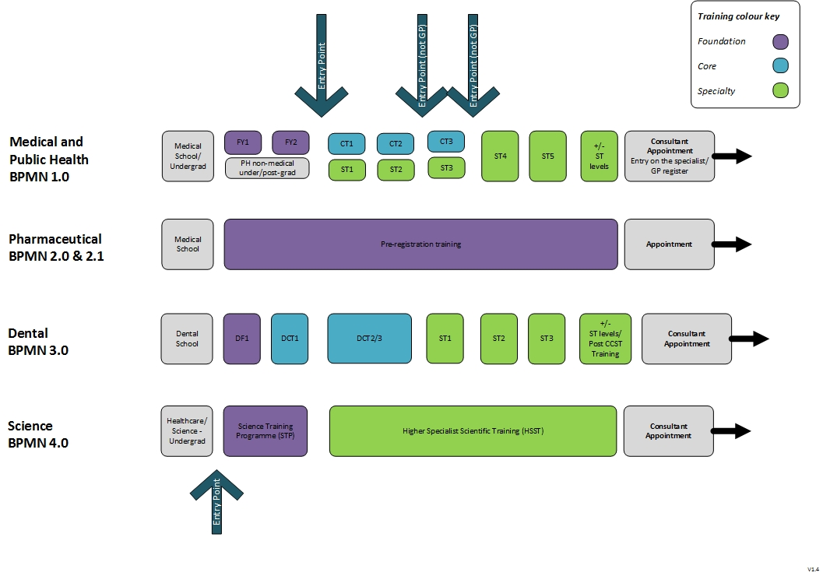

Annex J - Illustrative high-level processes for some learner-types

Key
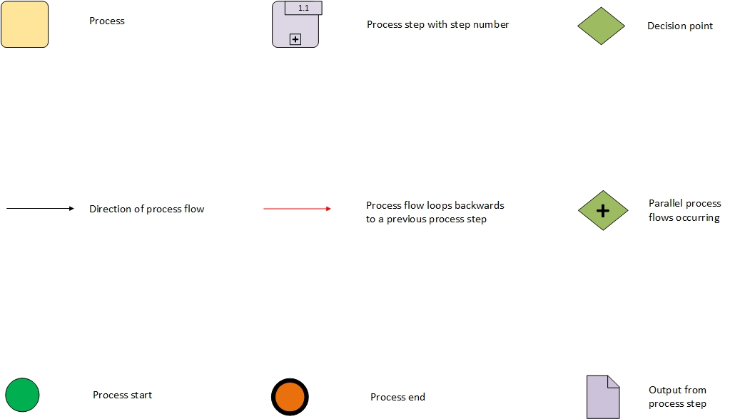
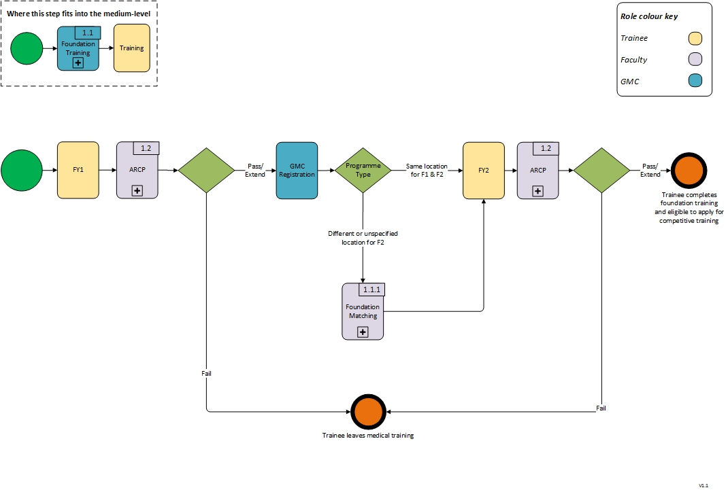
1.1 – Medical and Public Health foundation training
1.1.1 – Medical and Public Health foundation training matching process
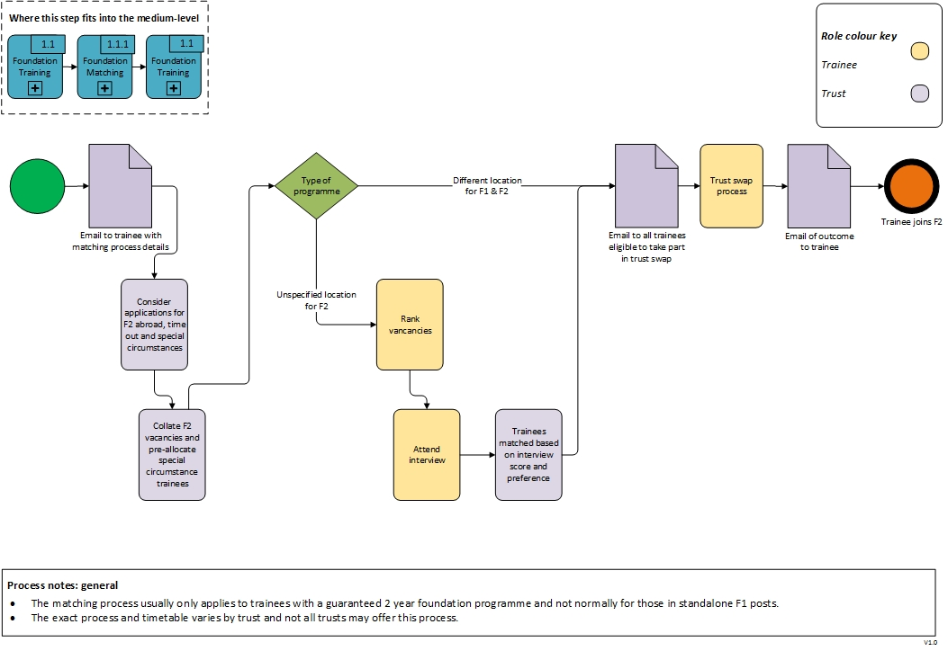

1.2 – Medical and Public Health ARCP
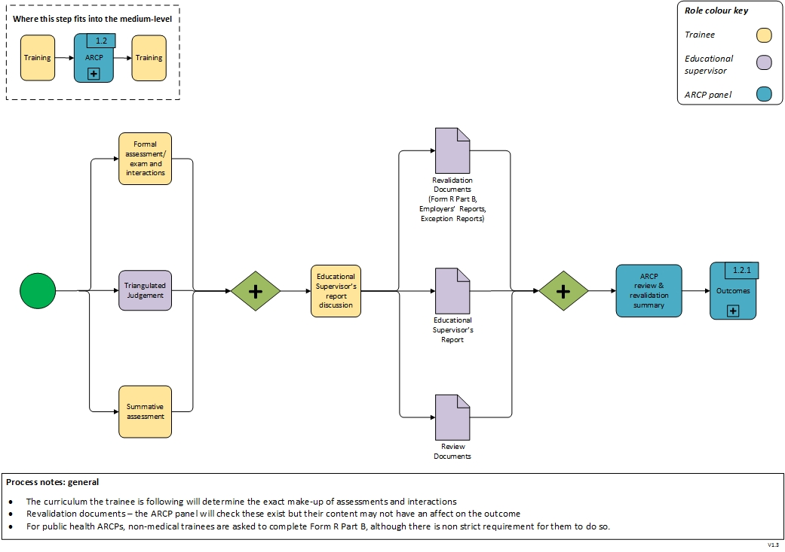

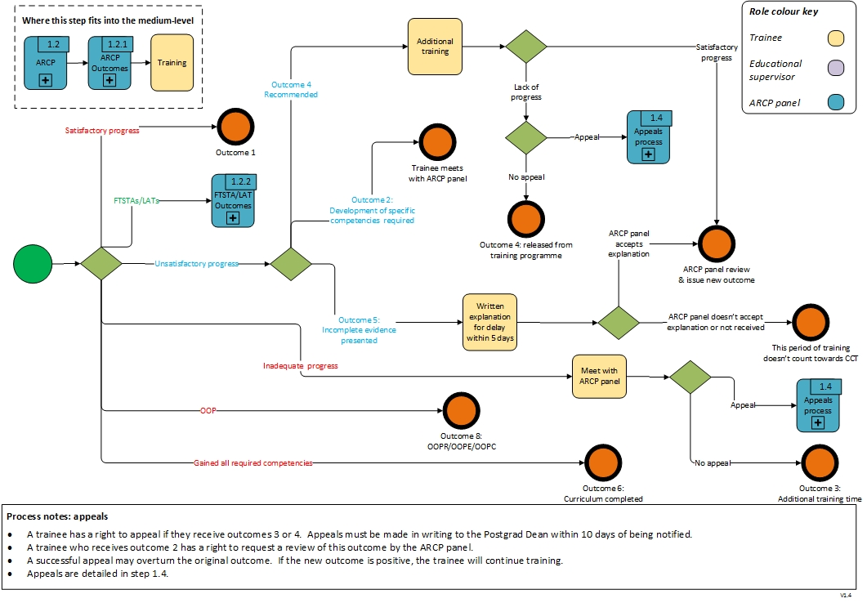
1.2.1 – Medical and Public Health ARCP outcomes (non-FTSTA/LAT)

1.2.2 – Medical and Public Health ARCP outcomes (FTSTA/LAT)
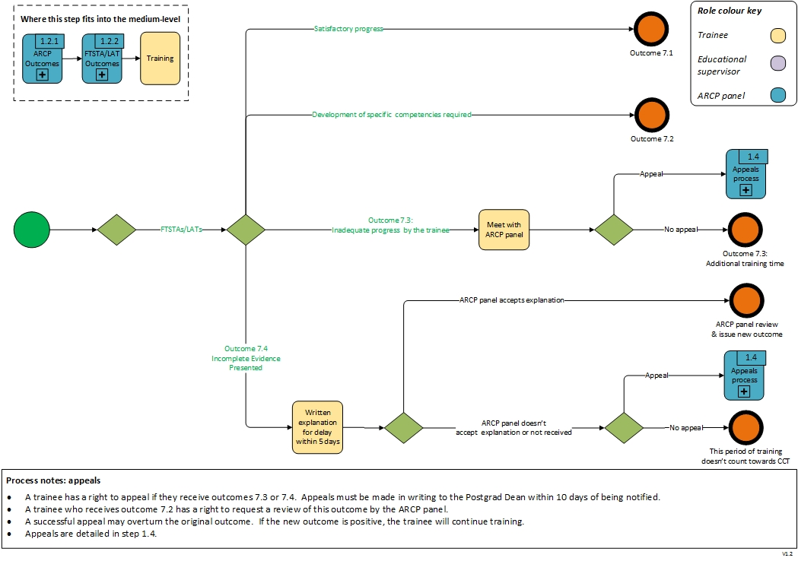
1.3 - Medical and Public Health revalidation
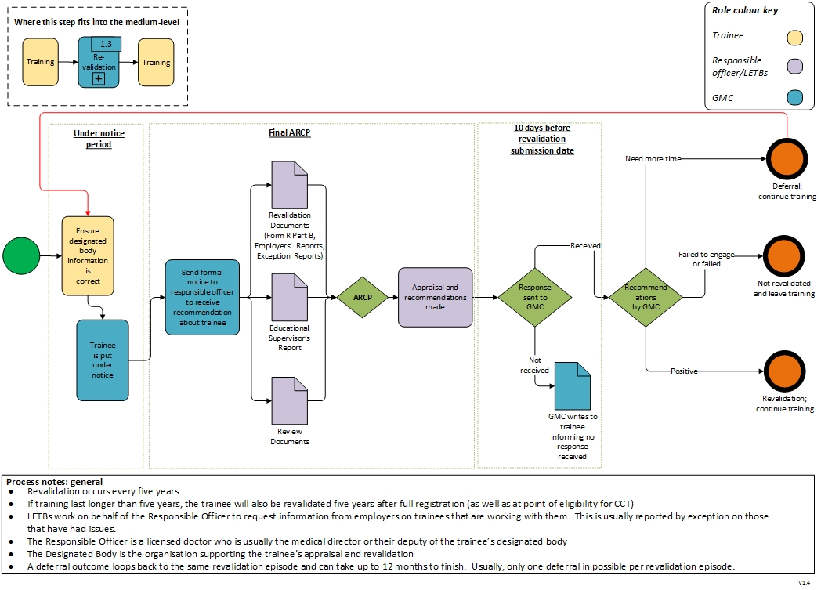
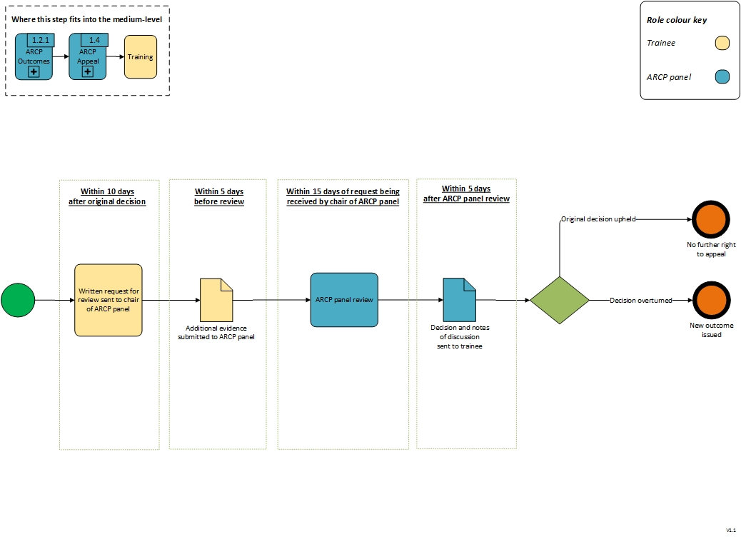
1.4 – Appeals process

Trainer approval process (medical)
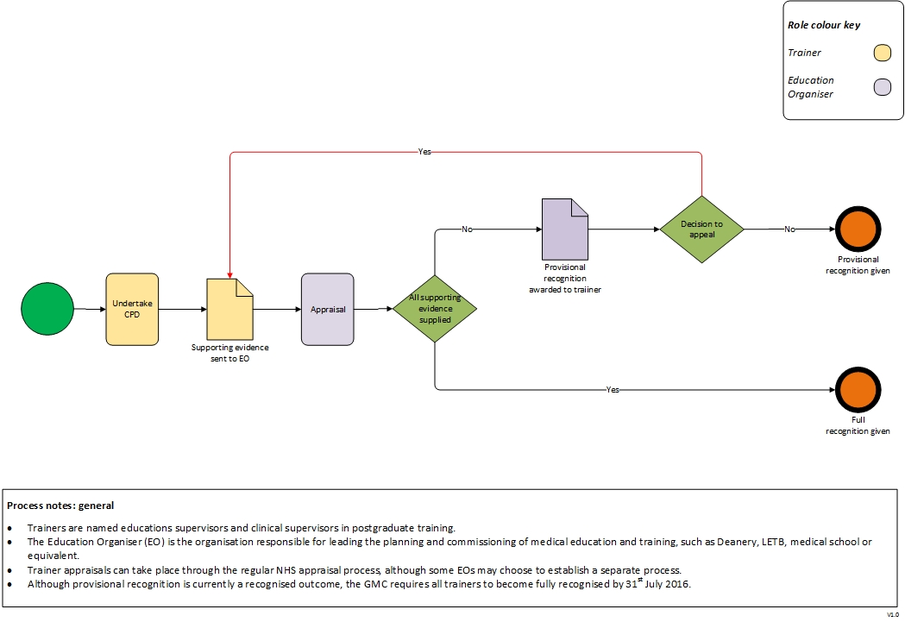
2.0 – Preregistration Pharmacist training
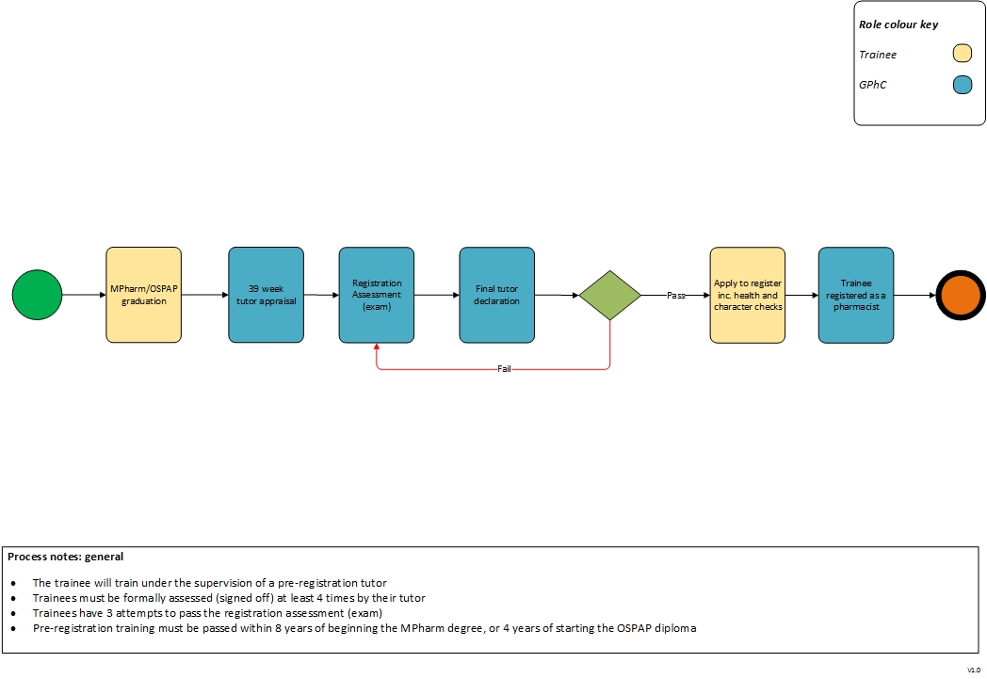
4.0 – Science training
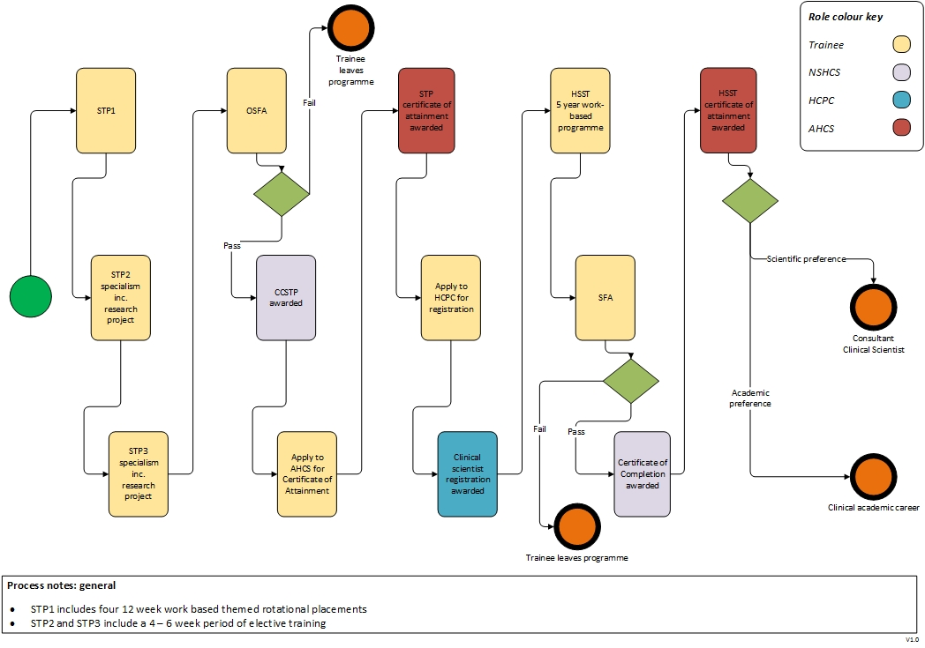

Annex K - User personas / archetypes

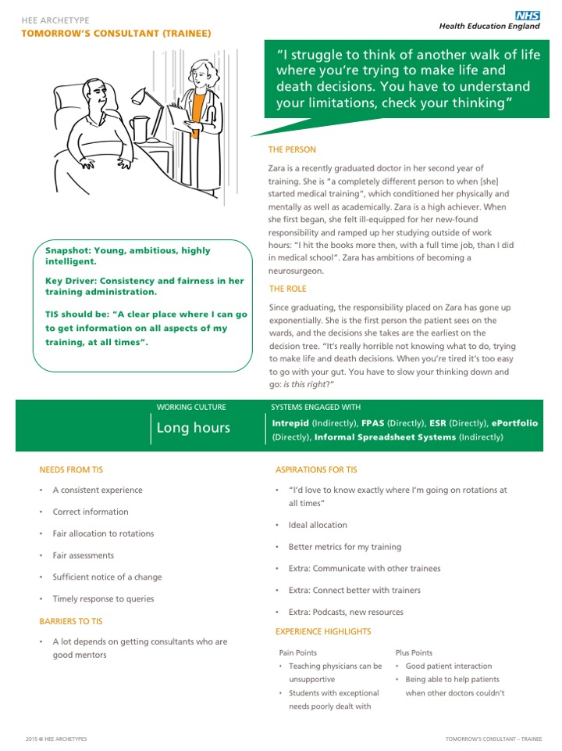

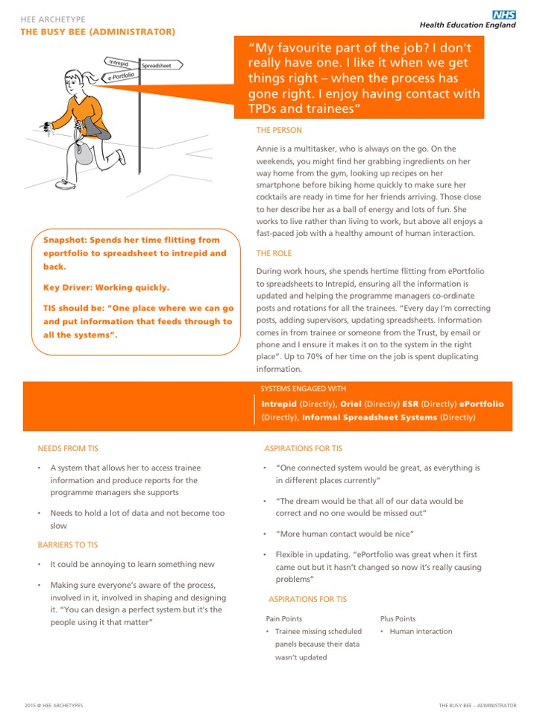

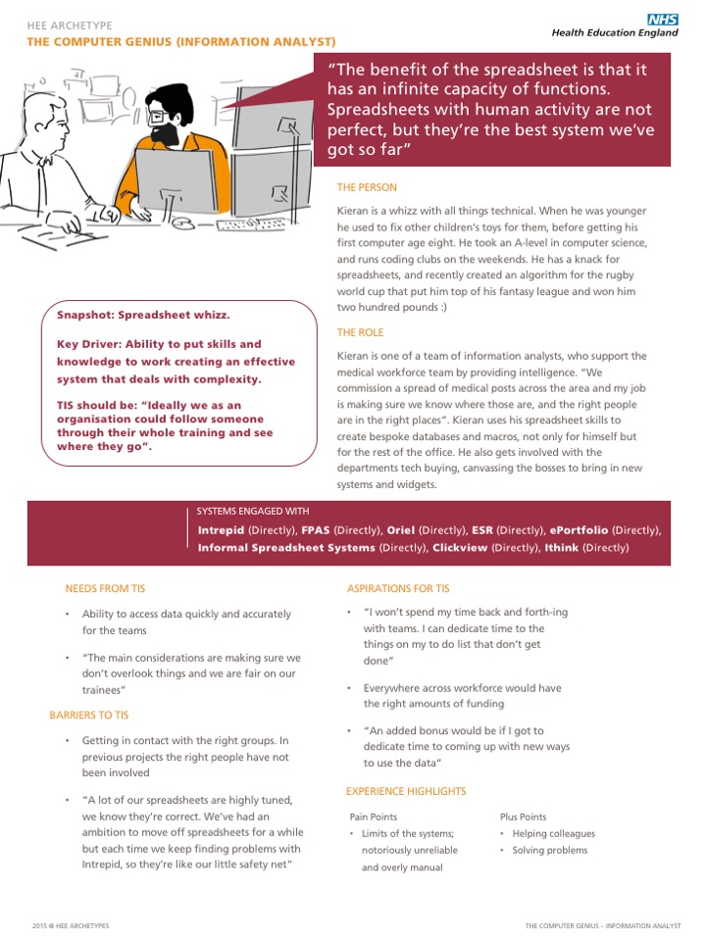

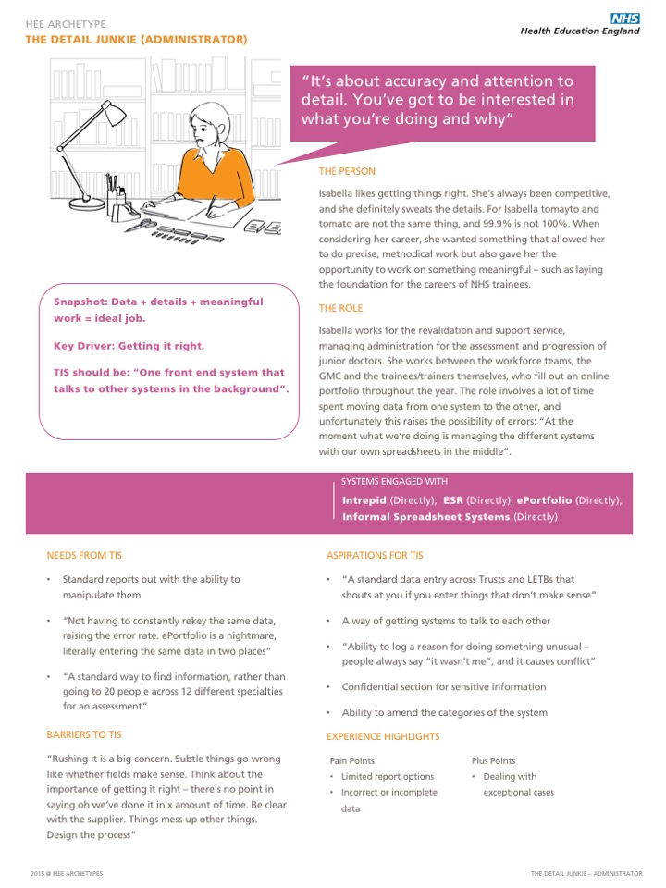

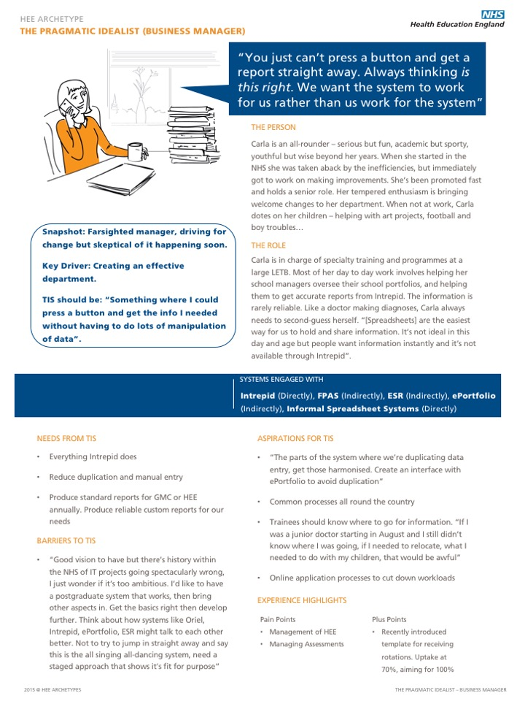

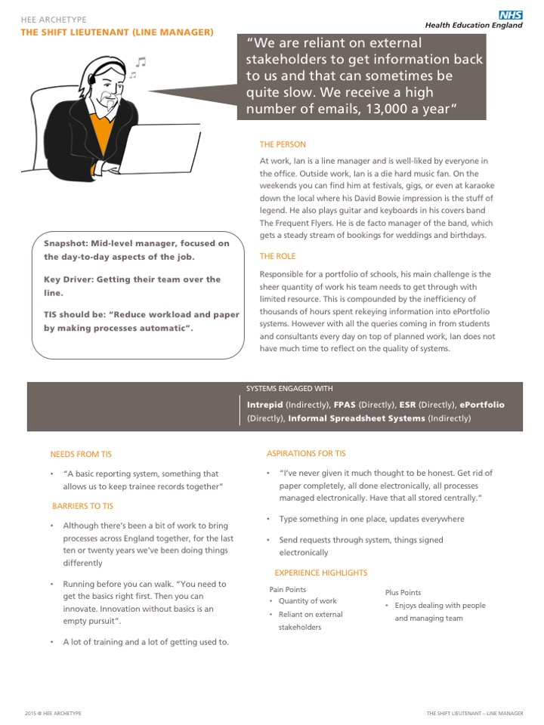

It should be noted that post tender the narrative, formative requirements and priority may be adjusted, expanded, or removed as part of further discovery work.
http://systems.hscic.gov.uk/data/learn/existing
http://www.datadictionary.nhs.uk/data_dictionary/messages/administrative_data_sets/data_sets/national_workforce_data_set_fr.asp?shownav=1
https://www.hesa.ac.uk/
https://ico.org.uk/for-organisations/guide-to-data-protection/key-definitions/
CCT is Certificate for Completion of training
http://www.electronicstaffrecord.nhs.uk/fileadmin/documents/esr_projects/Deanery/ESR-NHS00111_The_Streamlined_ESR_and_Deanery_System_Interface_Guide_v1_0.pdf
Out of programme should not be taken to mean the trainee is literally out of a (training) programme because a system principle is that all learners are in a programme. Out of programme may be more accurately defined as “out of training”.
http://www.jrcptb.org.uk/training-certification/penultimate-year-assessment
For example, prescribing Safely Results, induction etc.
http://www.gmc-uk.org/education/10264.asp
If the Devolved Administrations participate in the system, then there will be some organisational differences
http://www.electronicstaffrecord.nhs.uk/fileadmin/documents/esr_projects/Deanery/ESR-NHS00111_The_Streamlined_ESR_and_Deanery_System_Interface_Guide_v1_0.pdf

