Health Education England | Digital Transformation

Intrepid Screen Review

User Type: Trainee

Login Screen

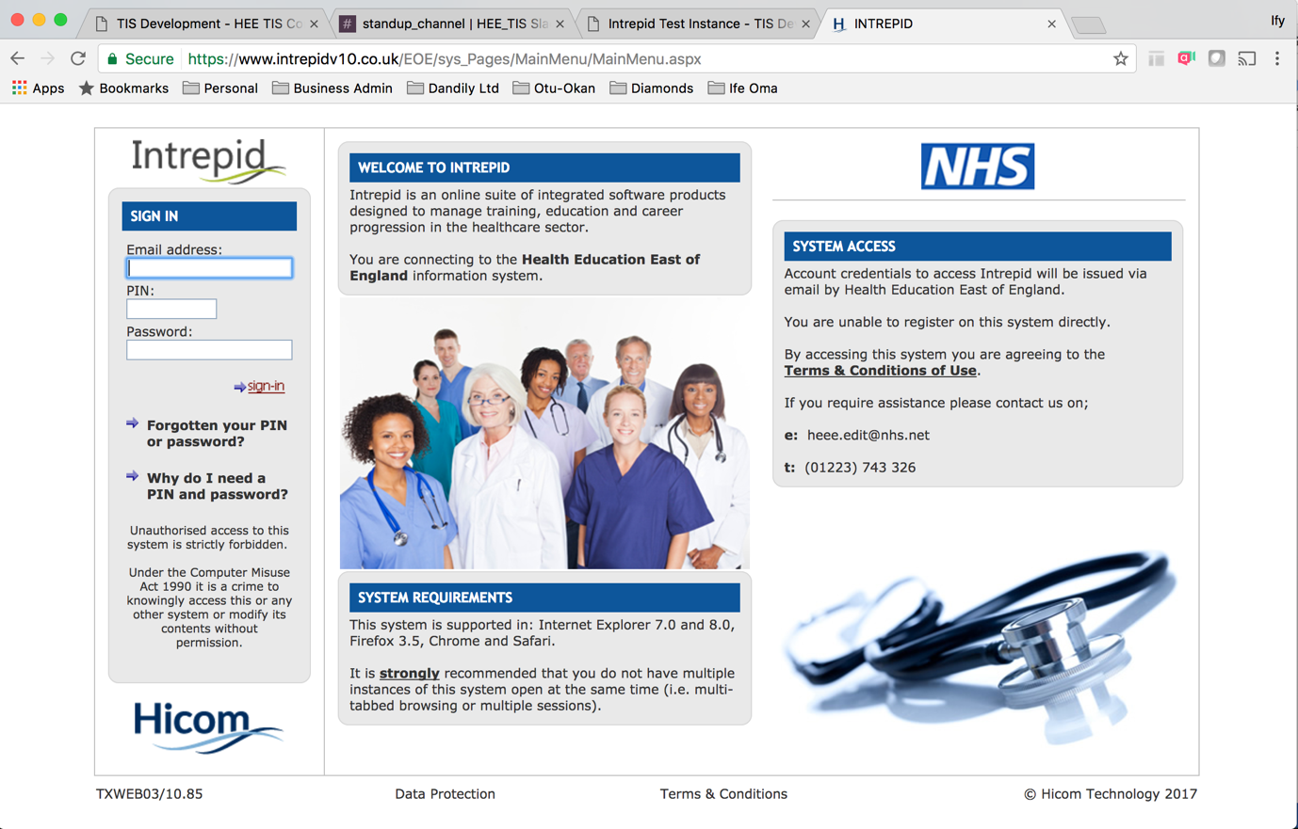

Functions:
- Allow user login
- Requires 3 level of data entry – username, pin, password
- Forgotten password
- Same for all user types

As a trainee, I need to be able to login using my existing credentials so that I can access my programme management details

As a trainee, I need to be able to change my password when it has been forgotten so that I can access my programme management details

As CIO, I need to display key legal notices at the point of login so that users are aware of restrictions on their access to the system

As XXX, I need to be able to display technical and system information at appropriate points in the user journey, so that users can easily access assistance whilst using the portal

As an admin, I need to be able to support trainee users through their password reset journey to ensure this action can be completed for them

Landing Page (logged in view)
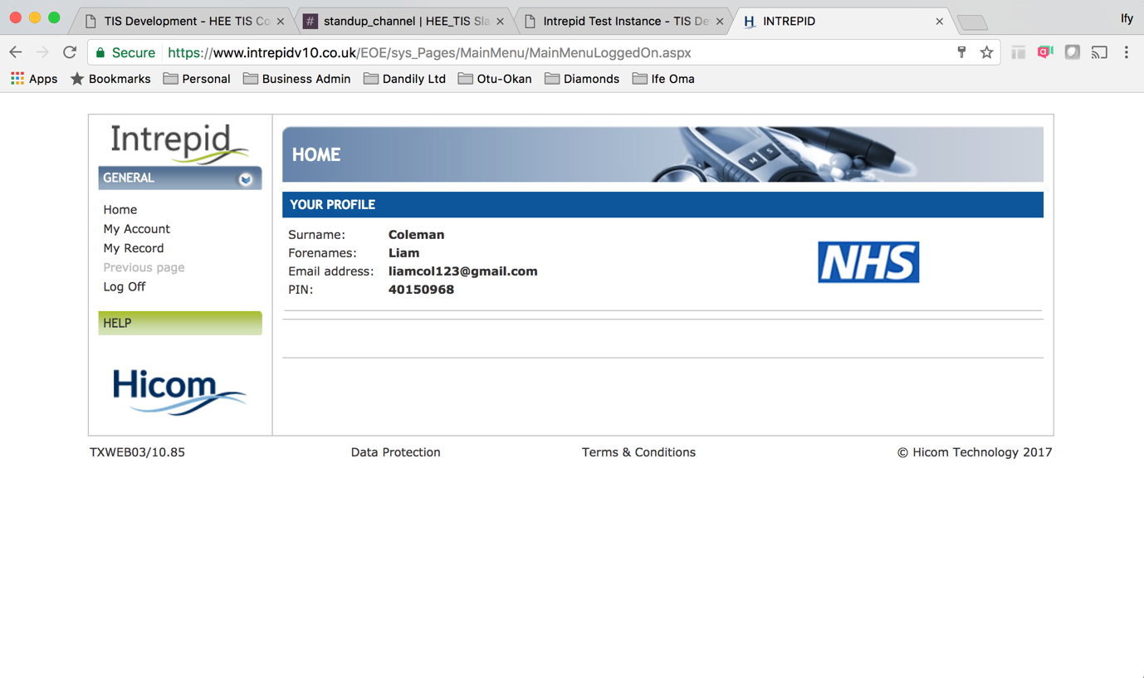
Functions:
- Navigate through user space (side navigation persistent throughout journey)
- View basic profile information
- Navigation expands once “record” is selected

As a trainee, I need to be able to view and edit my profile information so that it can be kept up to date within the system

As an admin, I need to be able to view/edit trainee profile information so that it can be kept up to date within the system

As a trainee user, I need to be able to navigate between the various functions available to me in a simple and clear way so that I can perform necessary tasks with ease

My Account
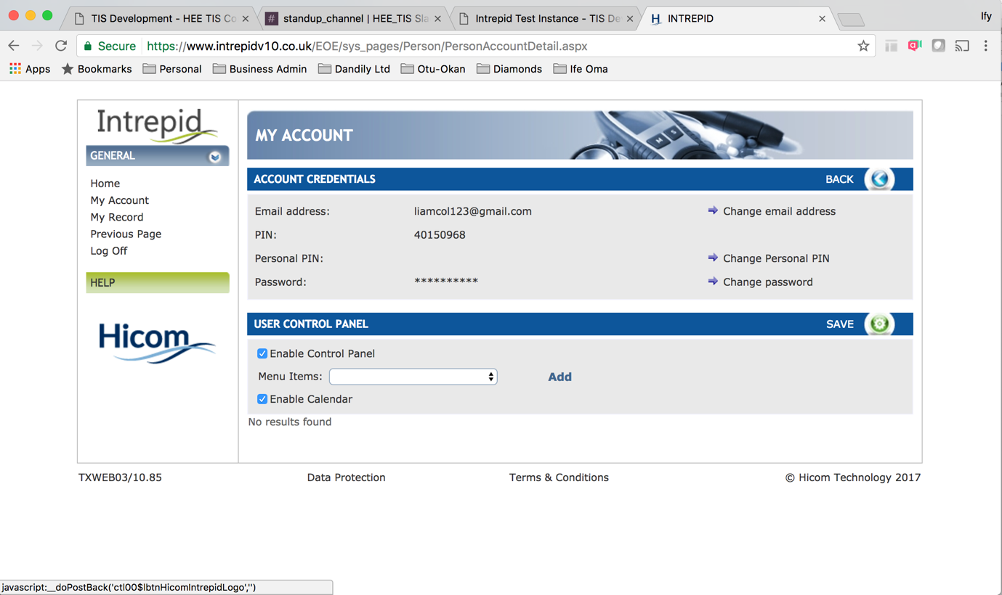

Functions:
- View/edit login credentials
- User control panel??

As a trainee, I need to be able to edit my user credentials (password, email address, pin) so that I can manage access to workspace

As an admin, I need to be able to support the edit credential journey, so that trainee users can complete this task

Profile
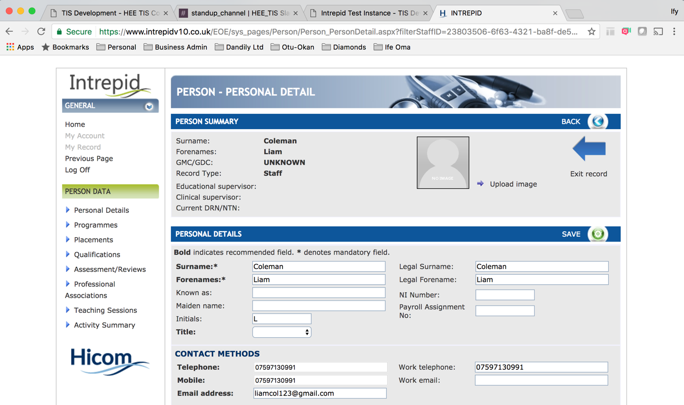
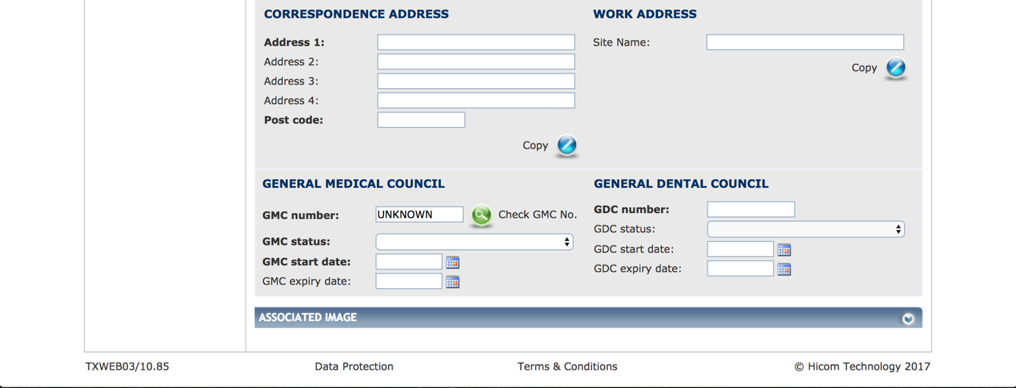

Functions:
- View/edit personal information
- Upload / edit image (non-mandatory) – 2 ways to upload a single image + guidance
- View / edit contact details
- View / edit GMC or GDC details

As a trainee, I need to be able to edit my personal and contact details so that my account can be kept up to date (fields TBD)

As a trainee, I need to be able to upload an image to my profile so that XXXX

As an admin, I need to be able to support profile update so that the trainee user can complete this process

Programme
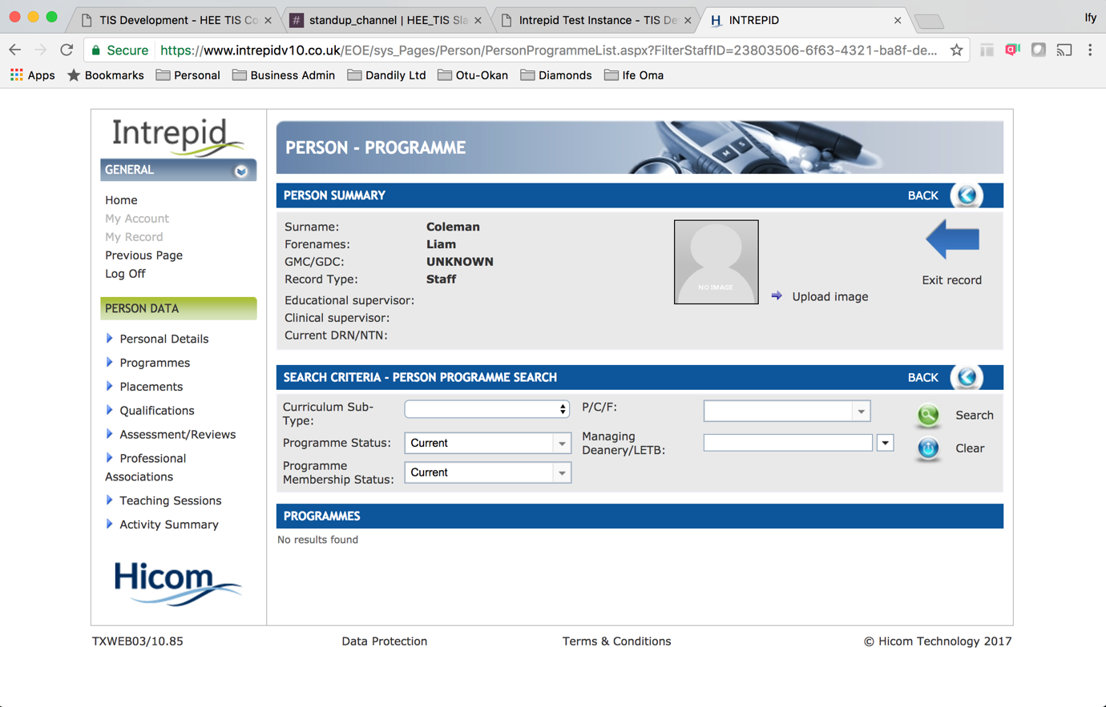

Functions
- View personal information
- Upload image
- View/add/edit programme information

As a trainee, I need to be able to select my preferred training plan (programme) so that I can trigger the process for assignment to the next stage of my training

As a trainee, I need to be able to view and edit my preferred training plan (programme) so that I can keep these details up to date and accurate

As a trainee, I need to be able to receive offline confirmation…??
As a trainee, I need to be able to see a log of changes made to my training plan??

Placement

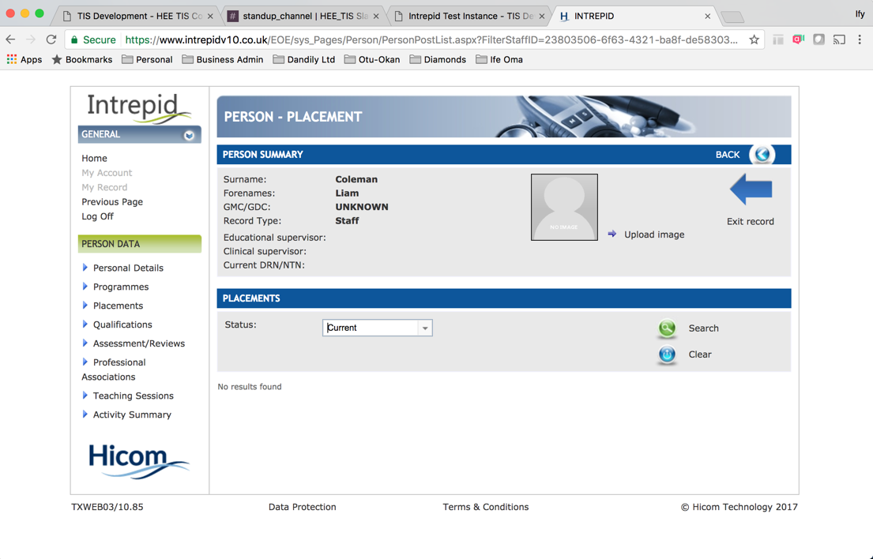

Functions:
- View personal information
- Upload image
- View placements and status of placements
- Search for…placements?
- Clear placements listed?

As a trainee, I need to be able to add/view/edit placement information so that I can keep my details up to date
- Sortable/filterable list
- Search for new placements
- View all available placements

As an admin, I should be able to support the add/view/edit placement information to ensure trainee users are able to do so

Qualification
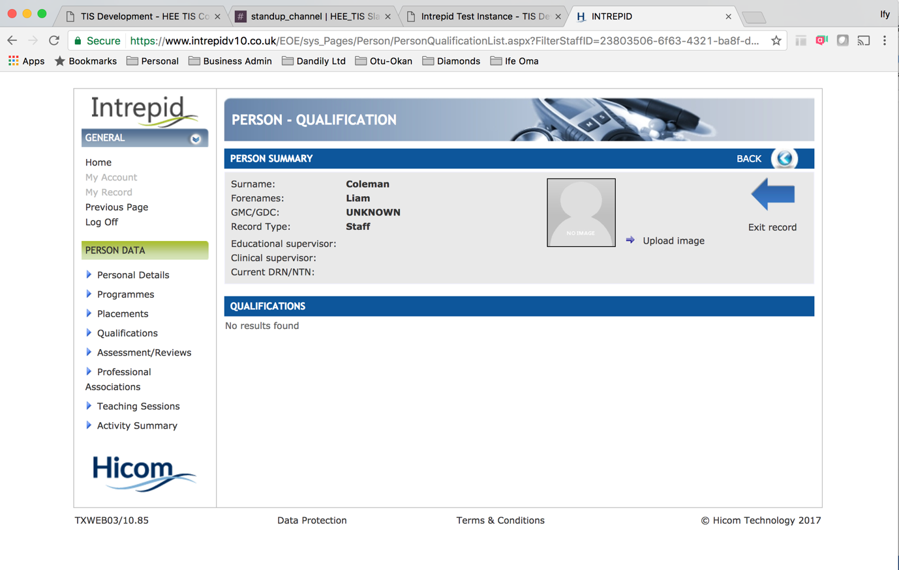

Functions
- View personal information
- Upload image
- View qualifications < - - where/when/by whom are these entered?

As a trainee I want to be able to add/view/edit my qualifications so that I can keep my profile information up to date

As an admin, I want to be able to support the add/view/edit qualifications for trainee users so that they can keep their information up to date

Assessment / Review
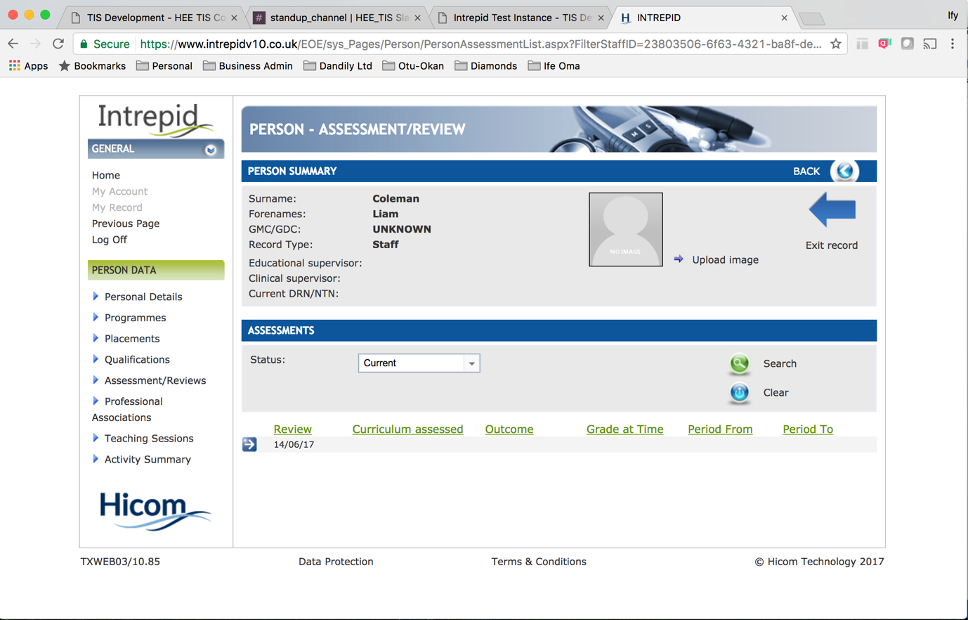

Functions
- View personal information
- Upload image
- View assessment outcomes < - - can these be explored for further details?

Professional Association
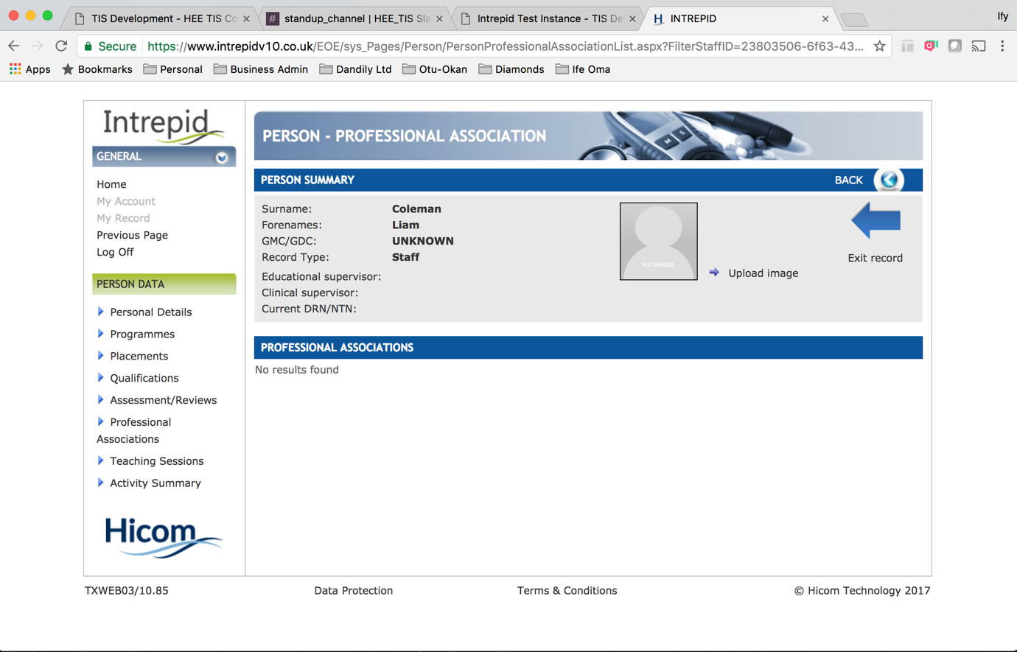

Functions
- View personal information
- Upload image
- View professional associations < - - who enters these, when and where?

Teaching Sessions
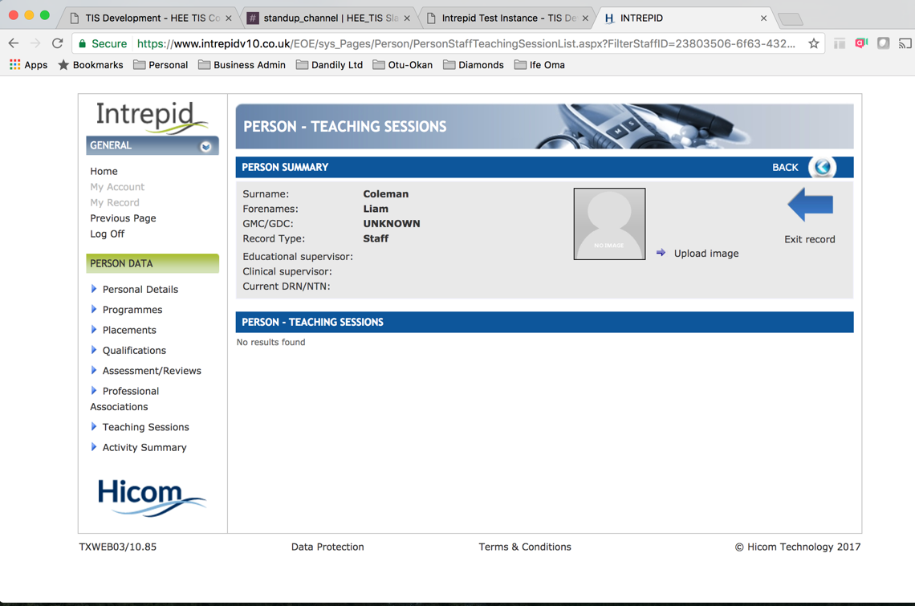

Functions
- View personal information
- Upload image
- View teaching sessions < - - who uploads, when, where

Activity Summary
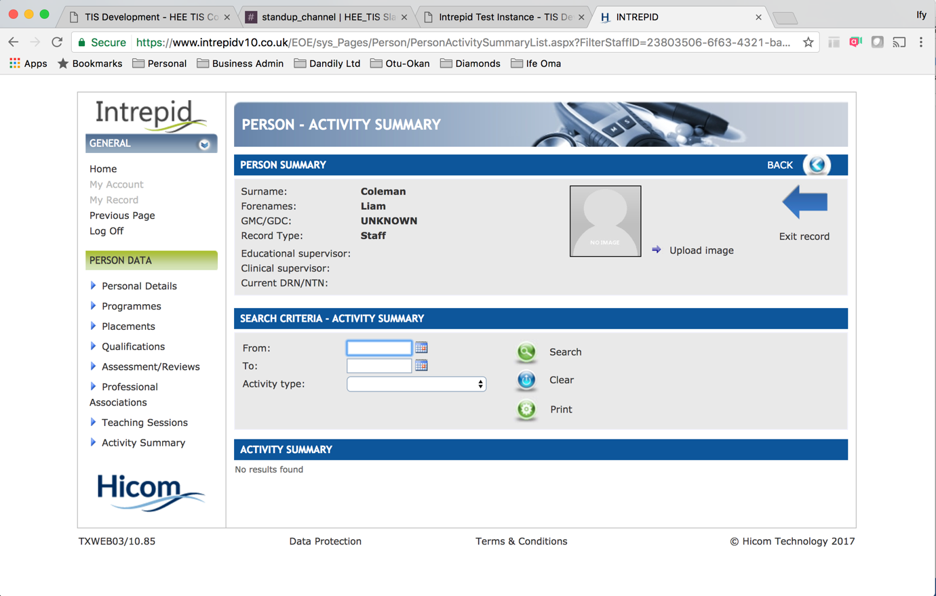

Functions
- View personal information
- Upload image
- View activity (course, leave, teaching session) via drop down within confined date span
- Print activity
- Clear search

**To be discussed further, what’s the purpose of this page?

Health Education England | Digital Transformation

Trainee Mobile App Screen Review

Login
- Enter username/password
- Login
- Further additions
  - Forgotten password
  - Register as a new user
  - Contact Support (via burger menu?)

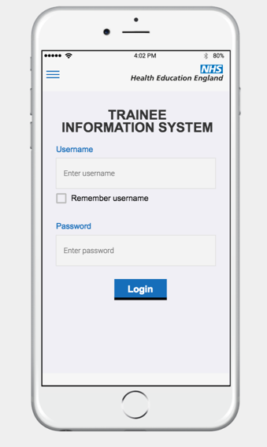

Dashboard – Logged In View

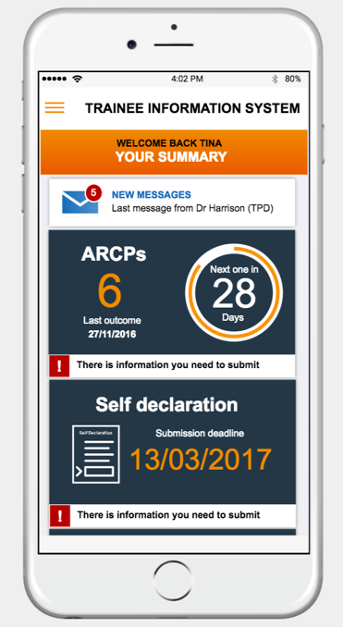
- View summary profile
- Reminders
  - Upcoming Assessment
  - Information Submission
  - Upcoming Placement?
  - Upcoming Review
- Messages received
  - Persistently displayed at top of screen
  - Links through to message centre?

Side-Navigation

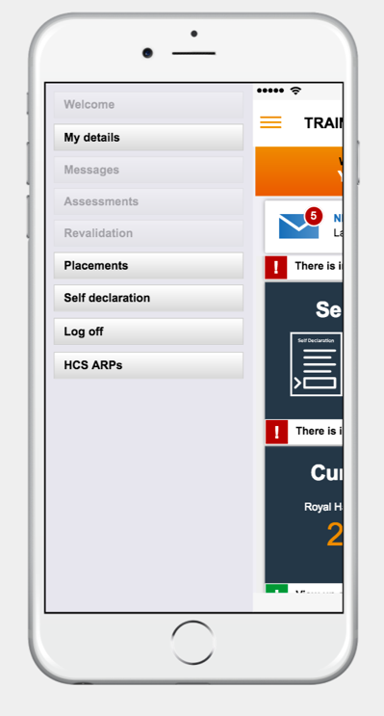
- View mega-navigation for app
- Click to go through to respective area of app
- Access to logout function

My Details - Personal
- Burger menu persistently available
- View / edit image
- View / edit personal & contact details – including immigration status
- Toggle to view Programme

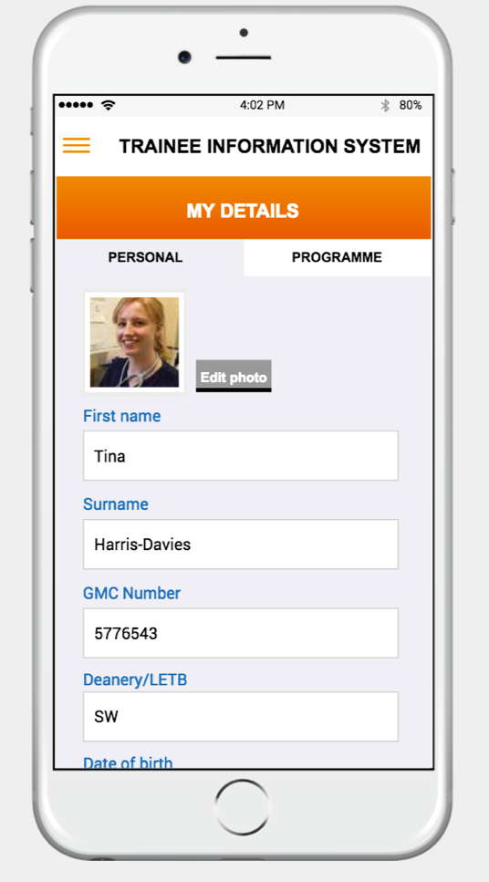

My Details – Programme
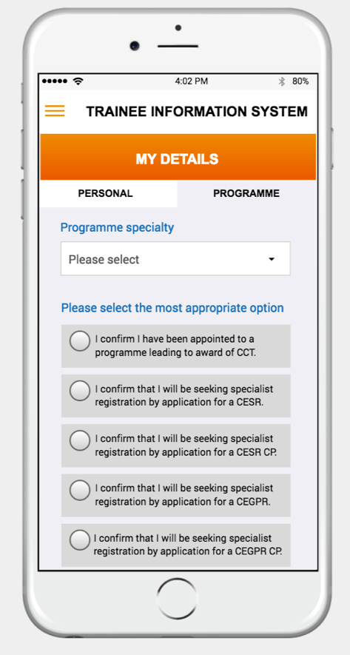

- Burger menu persistently available
- View / edit Programme Specialty
- Confirmation statements relating to TBD
- Answer questions relating to TBD
- Sign
- Toggle to Personal Details

Placements
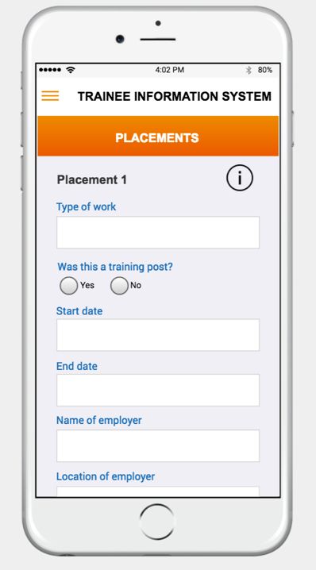
- Burger menu persistently available
- View / edit placement details – add multiple
- Add time out of training
- Submit

Self Declaration

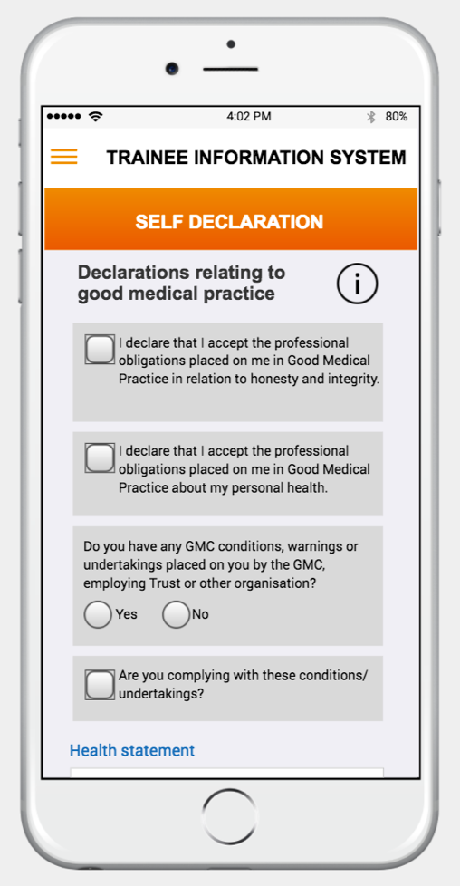
- Burger menu persistently available
- Complete / update self declaration details
- Sign

HCS ARPs – ARP Self Assessment

- Burger menu persistently available
- Complete / update self assessment details
- Toggle to view previous assessment details

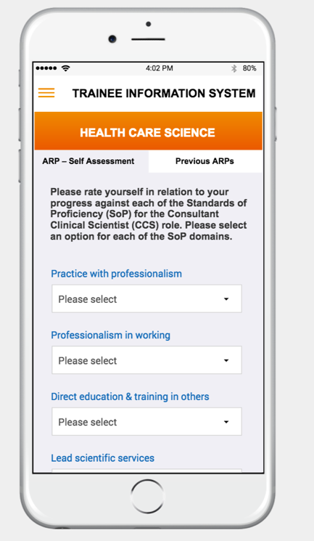

Question Log
Question | Answer | Comment
What are the questions relating to in the Programme?
What other systems do trainees use and what for?

